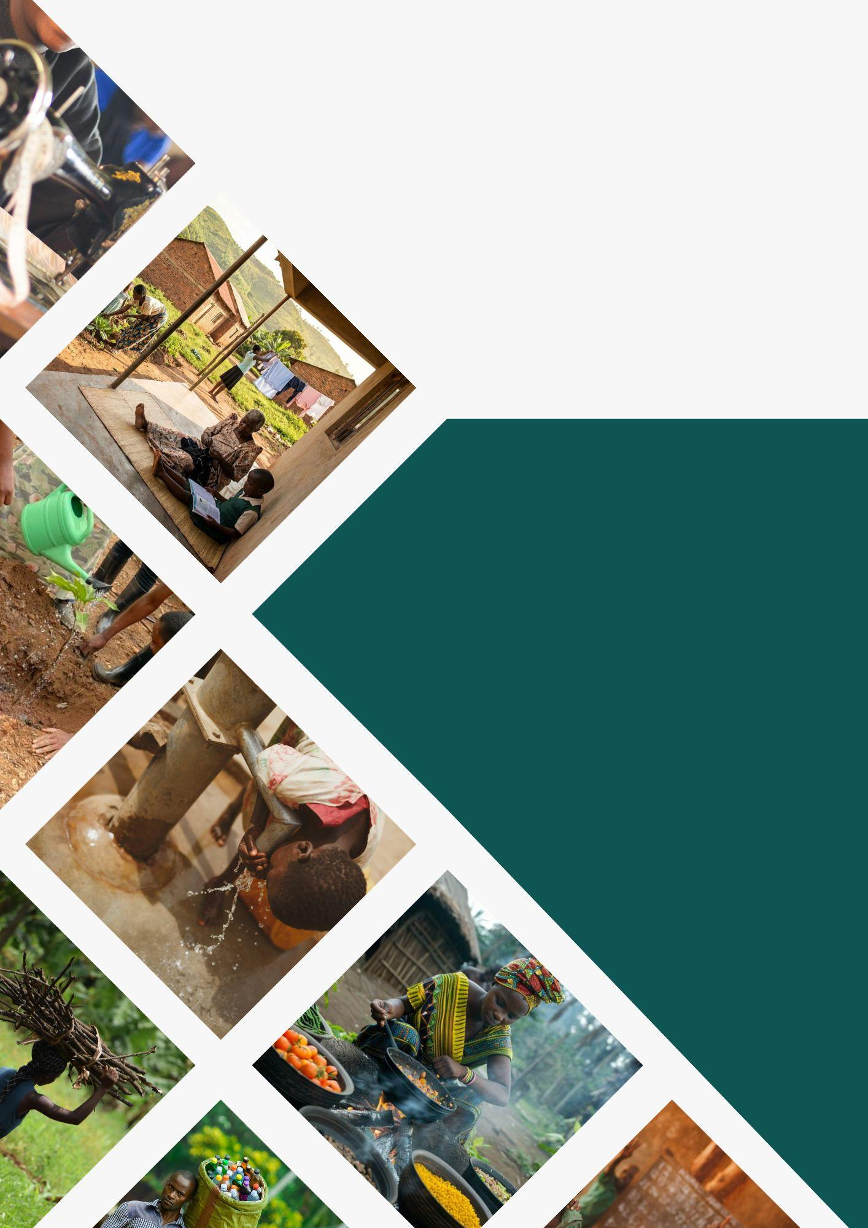
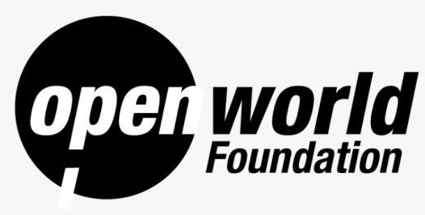

COUNTRY STRATEGIC PLAN (2026-2030)
“Opening Up The World Of Those In Need”

FOREWORD

Dear Partners, Stakeholders, and Friends of Open World Foundation,
As we stand at the threshold of 2026, we are filled with both gratitude and determination and would like to present to you our inaugural Strategic Plan (2026-2030).
Over the last two years of our dedicated work (particularly since our formal establishment), Open World Foundation (OWF) has remained committed to our purpose: opening up the world of those in need through transformative interventions in education, empowerment, livelihood, healthcare, and a safe environment, touching the lives of children, women, youth, and displaced communities across Uganda.
Our journey has deepened our conviction that true change begins with the most vulnerable, and with the continuously shrinking donor space in Uganda, the 2023-2025 Non-Governmental Organization (NGO) suspensions, and the recently passed sovereignty Protection of Sovereignty Act, 2026, the gap in service delivery is now wider than before. This is where we step forward to provide multisectoral support in Health, Education and Livelihood, to deliver on our goal that “the Youth (particularly those trapped in cycles of poverty and dependency) break free from poverty and dependency, achieve self-reliance, and reach their full potential, with sustained community-led support in education, livelihood, and health.”
This Strategic Plan 2026–2030 marks a bold new chapter. Building on our proven interventions carried out in the past two years, we commit to scaling our impact with greater depth and reach, working with new partners and collaborators within and outside Uganda. By 2030, we aspire to touch 20,000 lives of beneficiaries while gradually expanding our footprint from Uganda across East Africa and beyond (in strategic partnership with communities, governments, and like-minded organizations).
We are inspired by the courage of those we serve and humbled by the trust they place in us. This plan is not only a document; it is our collective promise to continue creating pathways to dignity, self-reliance, and hope.
Together, let us open wider doors to a more equitable and inclusive world.

ABBREVIATIONS/ ACRONYMS

OWF | Open World Foundation
SDG(s) | Sustainable Development Goal(s)
NDPIV | National Development Plan IV
HCD | Human Capital Development
CHS | Core Humanitarian Standards
UDHR | Universal Declaration of Human Rights
ICESCR | International Covenant on Economic, Social and Cultural Rights
UNFCCC | United Nations Framework Convention on Climate Change
CRRF | Comprehensive Refugee Response Framework
PESTLE | Political, Economic, Social, Technological, Legal and Environmental
SWOT | Strengths, Weaknesses, Opportunities, Threats
NPHC | National Population and Housing Census
UBOS | Uganda Bureau of Statistics (implied context)
ECE | Early Childhood Education
CBC | Competency-Based Curriculum
MIYCAN | Maternal, Infant, Young Child, and Adolescent Nutrition
IGAs | Income Generating Activities
NFIs | Non-Food Items
BCC | Behavioral Change Communication
MHM | Menstrual Hygiene Management
ICT / ICTs | Information and Communication Technology / Technologies
M&E | Monitoring and Evaluation
HoP | Head of Programmes
ED | Executive Director
GoU | Government of Uganda
NGO | Non-Governmental Organization
CSR | Corporate Social Responsibility
ToC | Theory of Change
KPIs | Key Performance Indicators

LIST OF TABLES
Table 1 PESTLE Analysis 9
Table 2 Targeted beneficiary groups for OWF interventions 19
Table 3 Monitoring and Evaluation Framework for the OWF 2026-2030 Strategic Plan 36
Table 4 Cost projection for implementation of the Strategic Plan ( in million ‘000,000’) UGX 44
Table 5 OWF Risk Register 46

LIST OF FIGURES
Figure 1 Image of a youth engaging in street vending to make ends meet 7
Figure 2 Cycle of poverty (OWF problem analysis) 13
Figure 3 Theory of Change 15
Figure 4 OWF Strategy Map 17
Figure 5 Targeted OWF locations for the period 2026-2030 18
Figure 6 A young lady moving to fetch water 23
Figure 7 OWF Crosscutting framework 31
Figure 8 Implementation Roadmap for the OWF Strategic Plan 33
Figure 9 Organogram to implement the strategic plan 34

TABLE OF CONTENTS

FOREWORD i
ABBREVIATIONS/ ACRONYMS ii
LIST OF TABLES iii
LIST OF FIGURES iii
TABLE OF CONTENTS iv
EXECUTIVE SUMMARY vi
1.0 INTRODUCTION 1
1.1 Organizational Background 1
1.2 Open World Foundation’s Value Proposition 3
1.3 Overview of OWF implementation period (2023-2025) 4
2.0 OVERVIEW OF THE STRATEGIC PLAN 7
2.1 Background 7
2.2 Rationale for Developing the Plan 7
2.3 Process of Developing the Plan 7
2.4 Alignment with national and international frameworks 8
3.0 SITUATION ANALYSIS 9
3.1 Macro context analysis 9
3.2 Micro context analysis 11
3.3 Problem analysis 12
3.3.1 The Nexus of the Problem – The Intergenerational Poverty Trap 13
4.0 STRATEGIC DIRECTION (2026-2030) 14
4.1 Overview 14
4.2 Vision 14
4.3 Mission 14
4.4 Theory of Change (ToC) 14
4.5.OWF Strategic Direction 2026-2030 17
4.5.1 Strategy Map 17
4.5.2 Strategic Target Groups 18
4.5.3 Strategic Objectives, outputs and strategic Actions 22
4.5.4 Cross Cutting Areas 31
5.0 IMPLEMENTATION ARRANGEMENTS 32
5.1 The Guiding principles for the strategic period 2026-2030 32
5.2 Phased Implementation Roadmap 33
5.3 Institutional structure for implementation of the Strategic Plan 34
6 MONITORING AND EVALUATION (M&E) FRAMEWORK 36
6.1 Monitoring and Evaluation Matrix 36
6.2 Learning and Accountability 41
7 SUSTAINABILITY AND LONG-TERM IMPACT 42
8 FINANCIAL MANAGEMENT PLAN 43
8.1 Resource Mobilisation and Funding Sources 43
8.2 The 5 Year Financial Requirement for implementation of the Strategic Plan 43
8.3 Financial Management Plan 44
8.4 Risk Analysis, and Safeguarding 46
8.4.1 Risk Management and Mitigation 46
8.4.2 Safeguarding 48

EXECUTIVE SUMMARY
Open World Foundation (OWF) is a Ugandan- based development organization committed to “opening up the world of those in need” through transformative interventions in health, education, and livelihoods. Since our legal establishment in 2023, we have delivered emergency relief, skills training, scholarships, and environmental initiatives across Uganda. This document marks the inaugural five-year strategic plan (2026–2030), developed as the first formal framework for OWF implementation within Uganda.
Anchored upon the theme “Empowerment for Self-sustainability,” this document provides a roadmap for OWF activities both internally (strengthening systems and processes) and externally (Empowerment of communities to reach their full potential).
Background
Uganda's demographic reality demands urgent action. With 75% of the population below 35 years, the country holds extraordinary potential, yet 50.9% of youth aged 18–30 is not in employment, education, or training. Additionally, an age dependency ratio of 83.8% means employed youth carry intergenerational burdens, leaving no room for personal growth. The strategic plan is grounded on the identification of poverty as a root cause - the intergenerational trap preventing young people from reaching their full potential. OWF’s problem analysis is grounded on the notion that poverty exists within a nexus of three interconnected gaps (health, education and livelihood).
- Without income, youth cannot afford health or education; without education, they lack skills for decent work; without health, they cannot learn or earn productively.
The OWF strategic plan 2026-2030 prescribes a HELP framework (Health, Education, and Livelihood Projects), breaking this cycle through three interconnected pillars where progress in any area strengthens the others.
Strategies Focus Areas for the period 2026-2030
- Under Pillar 1 (Health), the strategy centers on integrated service access, environmental health and hygiene, and nutrition security. OWF will overcome the triple barrier of distance, cost, and knowledge that prevents vulnerable youth from seeking care, while ensuring that health gains are not undermined by poor sanitation or malnutrition. Mental health and psychosocial support feature prominently, recognizing the invisible burdens of poverty and trauma.
- Under Pillar 2 (Education), OWF will focus on barrier removal, community ownership, and adaptive learning environments. The strategies will address the demographic, economic, and social obstacles that exclude vulnerable learners, while strengthening the ecosystem around them (teachers, parents, and community structures) to sustain gains beyond the implementation period.
- Under Pillar 3 (Livelihood), the strategic plan prioritizes enterprise development, employment linkages, and market-aligned skills. OWF recognizes that youth face dual exclusion from both formal labor markets and informal enterprise opportunities. Ar household-centered economic approach is therefore adopted, which ensures that income gains directly flow into health and education investments, breaking the dependency trap at its source.
- Pillar 4 (Institutional Capacity) ensures organizational sustainability through system strengthening, resource diversification, and partnership architecture. As a young organization, OWF must build credible, compliant, and transparent structures that earn community trust and donor confidence, while cultivating collaborative relationships that expand our reach and learning.
Six crosscutting areas (rights-based programming, community-driven processes, digital innovation, adaptive management, inclusive design, and environmental responsibility) are embedded across all pillars to guarantee that no intervention is siloed or exclusionary.
In the 2026-2030 period, OWF will implement across four priority sub-regions selected for consistently low indicators across health, education and livelihood sectors. Karamoja (Northern) which records Uganda's highest poverty headcount at 74.2%. Busoga (Eastern) which harbors approximately 840,700 people in absolute poverty and suffers jigger infestations, Rwenzori (Western) that has consistently reflected uneven poverty reduction and a high conflict prevalence., and Kampala (Central) which concentrates urban youth unemployment and is the hosting region for OWF headquarters for direct oversight.
OWF targets to reach 20,000 beneficiaries (both primary and secondary: 1000 youth-headed households for health, 1500 for livelihoods, 5,000 girls for menstrual hygiene support, 5 schools and 10 teachers for education quality, and 10 private-sector partners for employment linkages, household dependents, siblings, and caregivers among others will benefit through the household-level approach. The organization is also committed to 60% female-headed households, 5% PWD-headed, and 5% refugee-headed to ensure no one is left behind.
Implementation Framework
To implement the 2026-2030 Strategic Plan, a projection of UGX 20,227,143,750billion (App. USD 5.4Million) was made; mobilized from grants, philanthropists, corporate partnerships, and emerging sources including diaspora networks and social enterprise. This will be anchored upon a comprehensive resource mobilization plan which will be developed in the first year.
For sustainability, this strategic plan embeds localization (80% of staff from target regions), green humanitarian action and continuous policy alignment. Furthermore, the plan is strengthened by a comprehensive Monitoring and Evaluation (M&E) framework, a risk analysis plan, and five guiding principles that shape every implementation decision: stakeholder collaboration, accountability to the community, transparency and integrity, sustainability and long-term impact, and do no harm. These principles ensure that our interventions remain inclusive, ethical, and responsive to those we serve.
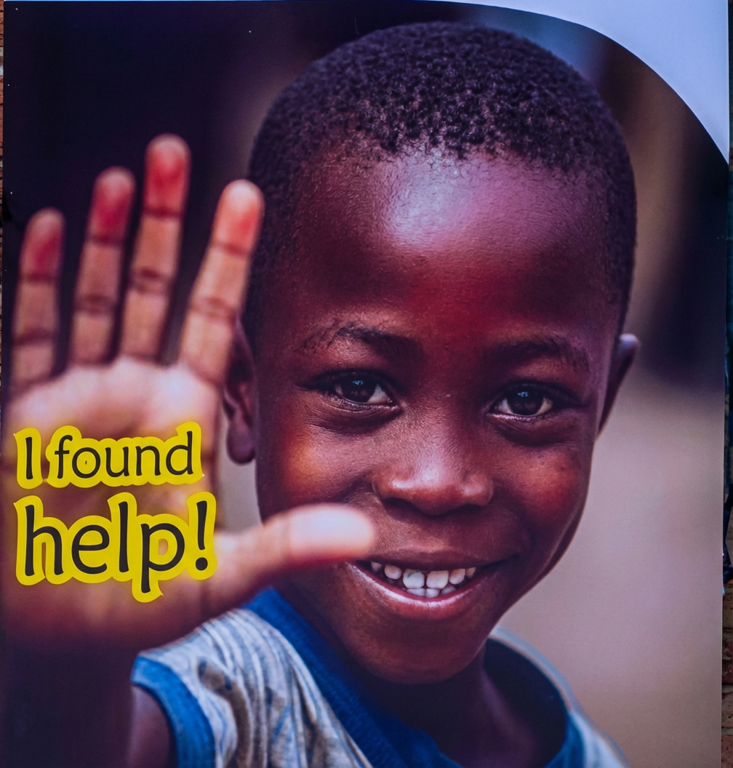

INTRODUCTION

1.1 Organizational Background
Open World Foundation (OWF) obtained its legal permit to operate in Uganda in 2023, marking the official beginning of our journey to openly make a positive impact on the lives of those in need. Despite this, our founders have been involved in improving lives of communities and providing humanitarian assistance for over 10 years with a special emphasis on education, health and skills improvement for youth groups in different communities. Our founders have also worked with several organizations both in Uganda and the wider East African Community, in designing, managing and monitoring projects, so as to expand their impact.

As a development organisation, we work towards an agenda to “Open Up the World of Those in Need,” demonstrating a collaborative effort to break down the barriers that keep vulnerable populations trapped in poverty and exclusion. We envisage existing opportunities as a folded map that vulnerable populations never get to see. OWF unfolds it - revealing routes to health facilities, schools, markets, and rights that were always there but invisible because of societal barriers.

To open up the world, we need young people, not only as recipients of support, but as the demographic force that constitutes the fastest-growing segment of the global workforce, driving technological adoption, digital entrepreneurship, and social innovation worldwide. It is against this background that OWF positions itself as a community-driven organisation that unlocks pathways to health, education, and livelihood for those trapped by poverty and exclusion, specifically the young people.

The Vision of Open World Foundation
As OWF, our aim is to create opportunities for young people whose potential is locked up by different vulnerabilities, for example, poverty, disability, natural disasters, illness, and abuse, among others. Our Vision is;

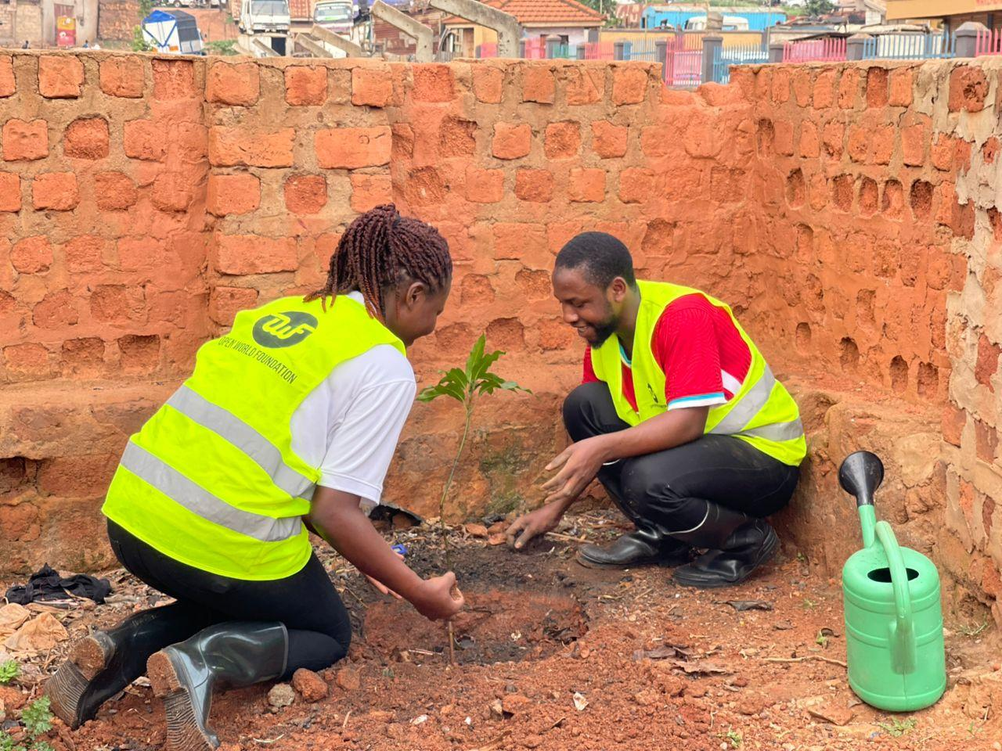
Vision: A world where every young person has the health, education, and livelihood to reach their full potential.
The Mission of Open World Foundation

- Human needs are dynamic and vast, and organizations need to be strengthened to address these needs as and when they arise. We have positioned ourselves as an agile and flexible humanitarian agency that can respond to the changing demands of vulnerable communities.

- Humanitarian agencies in Uganda are challenged by lengthy operational processes and bureaucratic structures that often create setbacks in meeting targets. As OWF, we strive to demonstrate our exemplariness in running lean structures and employing localized community-based approaches for accelerated decision making.

We are committed to a bottom-up approach because we believe that changing the world requires starting with the very fabric of the communities in which we live. Our aim is to work collaboratively with vulnerable and underserved groups, fostering sustainable development, education, and well-being to create a brighter, more equitable future for all.
Our Operational Distinctiveness

Mission: Empowering youth to break free from poverty through community-led solutions in health, education, and livelihoods to enable them to become self-reliant and stay there

Communities can only be empowered when projects emerge from within and are implemented from within. Our mission is therefore empowering communities, including the vulnerable, the leaders, and the donors, and especially the young people of Uganda, to utilize all channels available and accessible to create impactful transformations.

The Core Values of OWF
At the heart of OWF lies 6 core values that govern every aspect of our organization. These values define our culture and shape our approaches in provision of humanitarian support.
Table 1 Core Values of OWF
Value | Description
Service above self | We prioritise the needs of the communities we serve above personal interests or recognition.
Respect for Humanity | We uphold the dignity, rights, and worth of every Individual regardless of their background or circumstances.
Inclusion | We create spaces where diverse voices are heard, valued, and actively involved in decision-making
Transparency | We operate with honesty, openness, and accountability in all our actions and decisions.
Flexibility and Innovativeness | We adapt quickly to changing environments and emerging community needs, embracing creativity and thinking forward

1.2 Open World Foundation’s Value Proposition
This section defines OWF's value proposition: What distinguishes the organization within a competitive operating environment with shrinking civic space and declining donor funding. It articulates the distinct combination of strengths, and approaches that position the organization to deliver meaningful and sustainable impact within Uganda.

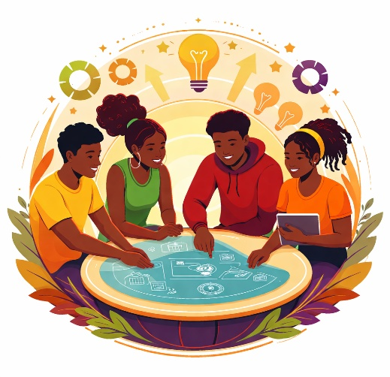

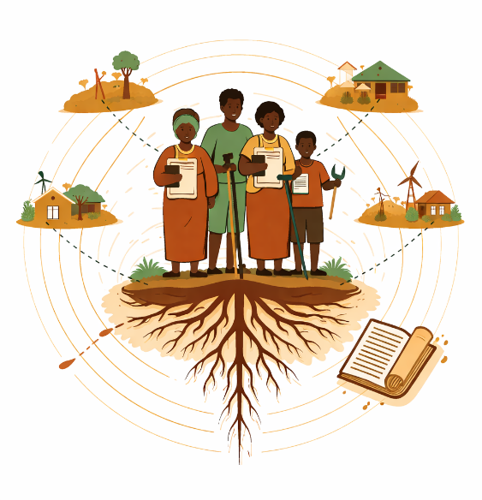
- Localization of Solutions
OWF grounds its work in the principle that “sustainable change emerges from within communities, not imposed from outside.” As such, our organization designs and delivers locally rooted solutions to locally identified problems, implemented by team members, partners and service providers who live in these communities. Our localization extends beyond program delivery to institutional memory, captured explicitly in OWF's manuals, policies, and proposals ensuring that approaches are contextually adapted, and institutionally embedded.
- Youth-Centered Programming
OWF's primary focus on young people directly aligns with Uganda's demographic reality, where 75% of the population is below 35 years of age. We believe that our targeting is not just a statistic, but an investment in future generations. Our organization positions young people at the center of design, implementation, and problem-solving, ensuring that interventions respond to actual youth-identified needs and harness their innovations to build ownership and sustainability.
3. Research-Informed Practice
OWF maintains a strategic partnership with a well-established research hub, providing access to technical expertise that strengthens the quality and credibility of its work. This collaboration ensures interventions are responsive to evidence rather than assumption, builds organizational capacity in learning and adaptability, and positions OWF to adjust programming based on emerging data and trends.

1.3 Overview of OWF implementation period (2023-2025)
The organization’s starting three years (2023-2025) remains a representation of the unyielding spirit of moving from an infancy stage into a growing one. Our main focus during this period was thus placed on strengthening internal core structures, establishing stakeholder relationships and listening to Ugandan communities to identify and refine the best approaches that serve as solutions to the country’s main challenges. Even in these groundwork stages, OWF delivered meaningful impact to several communities through several emergency and development initiatives that are presented below.
Emergency Relief support
Thematic Focus: Health, Education and Livelihood
Distributed Non-Food Items (NFIs) to victims of the August 2024 garbage dump landslide at Kiteezi, Uganda. This included items such as stationery (books, and pens), sanitary materials (soap, detergent, sanitary pads, etc.) We also interacted with various youth groups to give them comfort during the tragic moment. OWF also utilized social media to publicize the need and call upon different actors for support. Through this initiative, we:
- Restored dignity and hygiene for women and girls by providing Menstrual Hygiene Management (MHM) and protection needs during the crisis.
- Provided psychosocial comfort and solidarity with youth groups through direct engagement, helping young people cope with trauma and loss.
- Amplified the emergency appeal by utilizing social media to publicize the need and mobilize broader support from different actors, expanding the reach and response beyond OWF's direct capacity.

Thematic Focus: Health, and Livelihood
Conducted one outreach at Friendship Village (Takajunge on Kayunga Road) in Mukono District. This village was established in 2007 to provide targeted livelihood support for women living with HIV/AIDS through a community approach, originally with 133 homes. As OWF, we extended our support through provision of both Food (rice, cooking oil, sugar, posho) and Non-Food Item (NFIs) such as clothing and beddings, sanitary pads, and other WASH materials to up to 50 households. The impact has been visible in the tangible cost savings to these households, that allowed them to re-direct their resources towards other essential needs. Through this initiative, OWF, we achieved the following.
- Alleviated immediate food insecurity for up to 50 vulnerable households by providing essential supplies, ensuring nutritional support for families affected by HIV/AIDS.
- Improved living conditions through the distribution of critical non-food items, addressing basic needs that are often deprioritized due to financial constraints.
- Generated tangible cost savings for beneficiary households, enabling them to redirect limited resources toward other essential needs such as healthcare, education, and livelihood investments.

Development Interventions (Livelihood and Education)

Thematic Focus: Livelihood and Education
Conducted 5 trainings for 45 Youths, whereby 35 were linked with temporary employment and 1 with permanent employment. We also created awareness to 2 Private sector partners on the need for skilling and employing youths, purchased and distributed 10 mobile-based tablets to youth for research, data collection and search for job opportunities. This enabled us to secure two long-term partnerships with private sector companies (Eureka Place Hotel and Analysis Group Company). Through this initiative, we:
- Enhanced youth employability, with 80% of the beneficiaries successfully linked to employment opportunities and established sustainable employment pathways by creating direct linkages between trained youth and private sector employers.

Thematic Focus: Education
In collaboration with Adroit Consult International, we provided two full scholarship opportunities for young people in secondary and tertiary education. One of the learners (female) was able to transition to Upper secondary education, and the other has managed to successfully graduate from Makerere University. Through this initiative, we;
- Enabled educational progression for marginalized groups who successfully transitioned to Upper Secondary education, and completed tertiary education, contributing to improved gender equity in educational attainment.
- Strengthened institutional partnerships and collaborations to expand access to education for disadvantaged young people.

Thematic Focus: Health and Environment
Supported tree planting in Kiggundu and Sebina Zone, Makerere Kavule- Kampala as part of greening effort for the co-building of low-cost flood resilient tributaries carried out by our partners. Palm trees for shade and fruit trees for nutrition were selected due to resilience and additional benefit provided to communities. Through this initiative, we;
- Advanced sustainable urban greening practices in Kampala's vulnerable neighborhoods, supporting both ecological restoration and community livelihood.

Thematic Focus: Health and Environment
Carried out 5 mental wellness campaigns through bicycle riding activities within and outside Kampala for urban youth.
- Fostered social connection and community belonging among urban youth through group cycling, reducing isolation and building peer support networks.
- Enhanced physical and emotional resilience by integrating exercise into accessible, low-cost mental health programming.

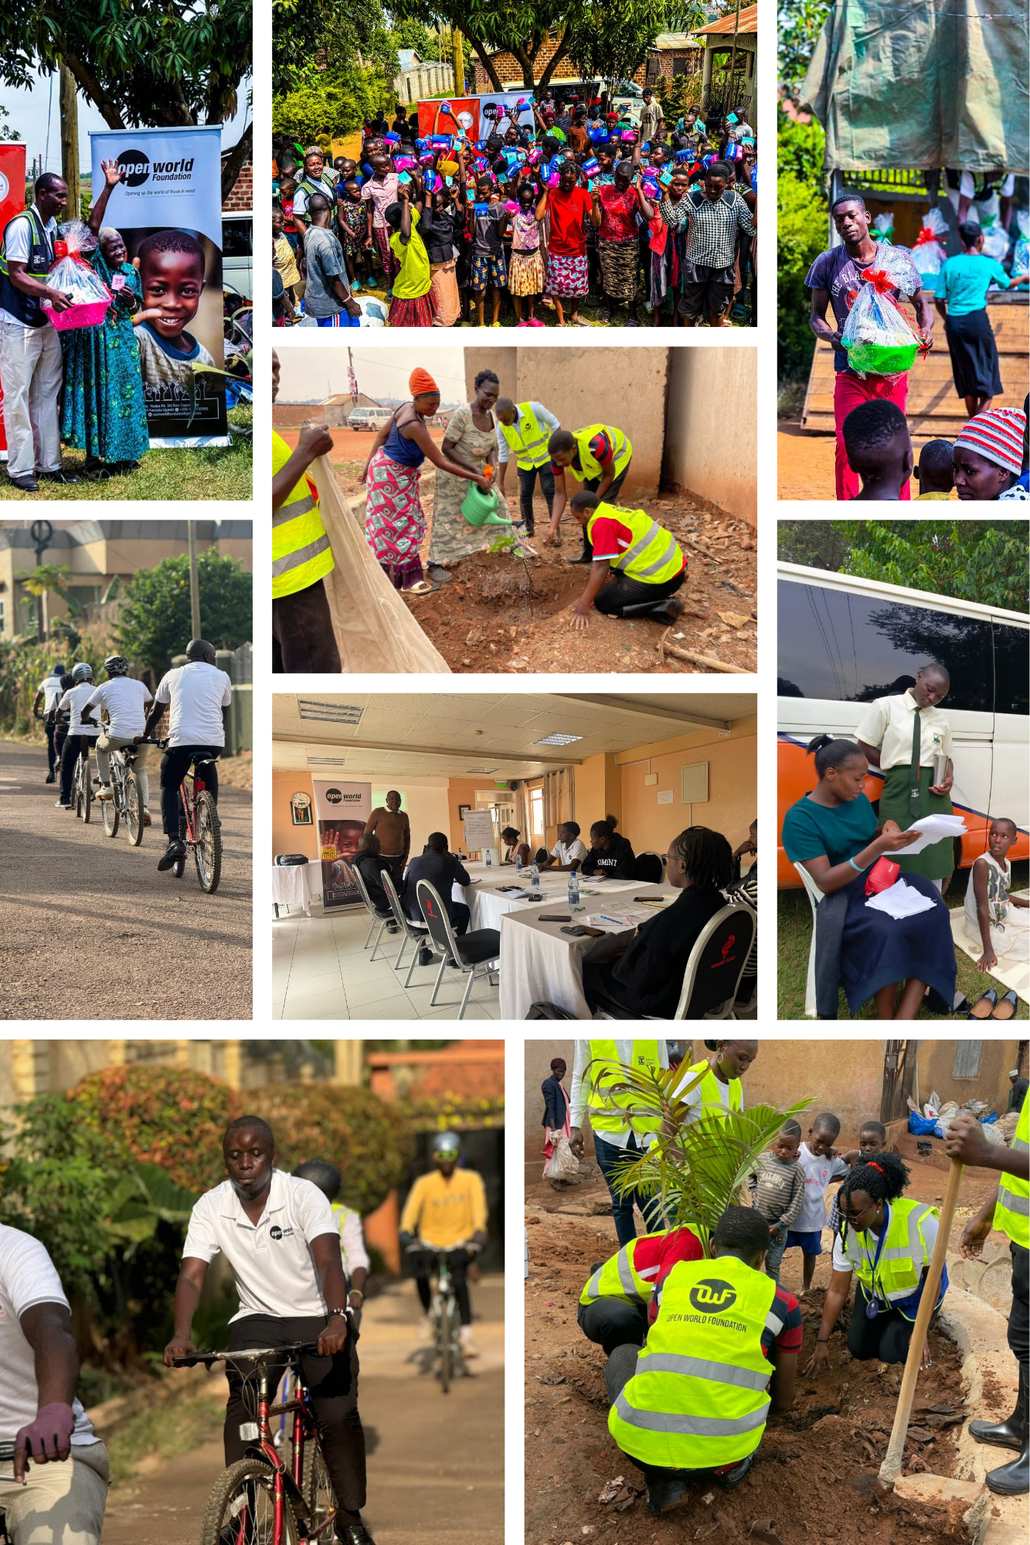

OVERVIEW OF THE STRATEGIC PLAN
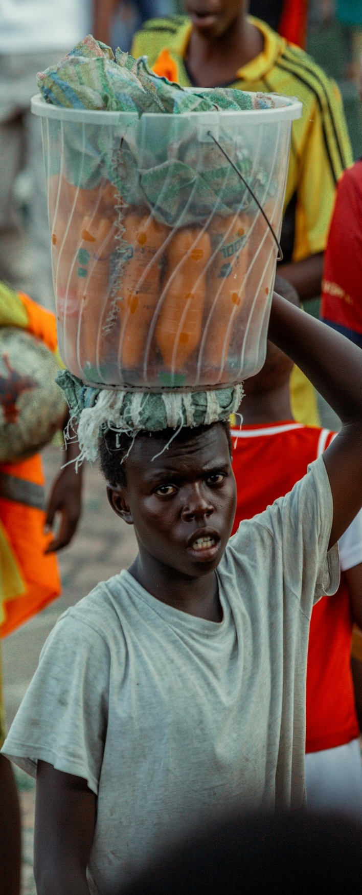
Figure 1 Image of a youth engaging in street vending to make ends meet

2.1 Background
This document marks the first and inaugural Sstrategic Plan (SP) of OWF covering the period 2026 - 2030 and representing a key milestone in our journey as a new but growing organization in Uganda.
Anchored on the theme of “Empowerment for Self - Sustainability,” the plan elaborates on OWF’s core strategy of supporting vulnerable communities (especially the young household heads) to identify challenges and develop interventions that bring about change.

2.2 Rationale for Developing the Plan
The OWF Strategic Plan (2026-2030) constitutes the organization’s first formal framework for its implementation within Uganda. The document provides a roadmap for our activities both internally (to strengthen our systems and processes in line with our vision) and externally (to empower communities in line with our mission). The strategic plan will thus not only provide a foundation to transform initial ideas into actionable, impactful operations, but also enable the right programmes to be implemented, build channels for accountability, adaptability and stakeholder alignment, and serve as a partnerships and resource mobilization tool.

2.3 Process of Developing the Plan
The strategic plan was developed in wide consultations with key internal stakeholders of OWF including, but not limited to, the Board of Directors, the management and the technical and administrative. Up to 5 consultation and validation workshops were organized to reflect, refine and agree on the priority areas for OWF within the period 2026-2030. Furthermore, 10 group discussions were held with communities in marginalized areas within Uganda to identify the root causes of the challenges they face. This data was then triangulated with a review National and International policies and Frameworks, the National Population and Housing Census (NPHC), 2024, reports by other Non-Governmental Organizations (NGOs), and other studies examining contextual and underlying vulnerabilities.

Far from replicating conventional models, this strategic plan has been tailored to address the evolving realities in Uganda. As such, it contains a comprehensive macro environmental analysis covering Political, Economic, Social, Technological, Legal and Environmental context analysis (PESTLE), and micro environmental analysis through a Strengths Weaknesses Opportunities Threats (SWOT) tool. All these processes aided in prioritization of the main internal and external pillars for the SP 2026-2030.

2.4 Alignment with national and international frameworks

International Frameworks
The OWF strategic plan (2026-2030) is aligned to the United Nations Sustainable Development Goals (SDG)s that are geared towards ending poverty, achieving food security, improving nutrition, promoting sustainable livelihoods, gender equality, quality education, and building resilience. This alignment is evidenced by the overall focus on the strategic plan theme.

More specifically, the overall impact and goal of this plan is directly aligned with SDG 1 (No Poverty), while the key strategies proposed speak to the objectives of SDG 3 (Good Health and Well-being), SDG 6 (Clean Water and Sanitation) SDG 4 (Quality Education) SDG 8 (Decent Work and Economic Growth), SDG 2 (Zero Hunger), SDG 5 (Gender Equality), SDG 10 (Reduced Inequalities), SDG 7 (Affordable and Clean energy) and SDG 13 (Climate action).

Beyond the broader goal, the approaches in this strategic plan are also in line with key frameworks such as; the Core Humanitarian Standards (CHS), The Universal Declaration of Human Rights (UDHR); International Covenant on Economic, Social and Cultural Rights (ICESCR); The United Nations Framework Convention on Climate Change (UNFCCC); UN Human Rights framework, and the Comprehensive Refugee Response Framework (CRRF), among others.

National Frameworks
Uganda National Development Plan IV (NDPIV) for 2025/26–2029/30, a move towards Vision 2040, places emphasis on Human Capital Development, sustainable resource management, and economic transformation. OWF aligns with this through strategies that uplift youth in areas of capacity, development, education, health and livelihoods. Furthermore, we as OWF have designed this strategic plan (2026-2030) in alignment with key frameworks such as the Uganda Nutrition Action Plan and policies such as the National Gender Policy, National Youth Policy, National Social Protection Policy, among others.

The continuous alignment with national frameworks will be ensured by partnerships and collaborations with the Government of Uganda in our activities.

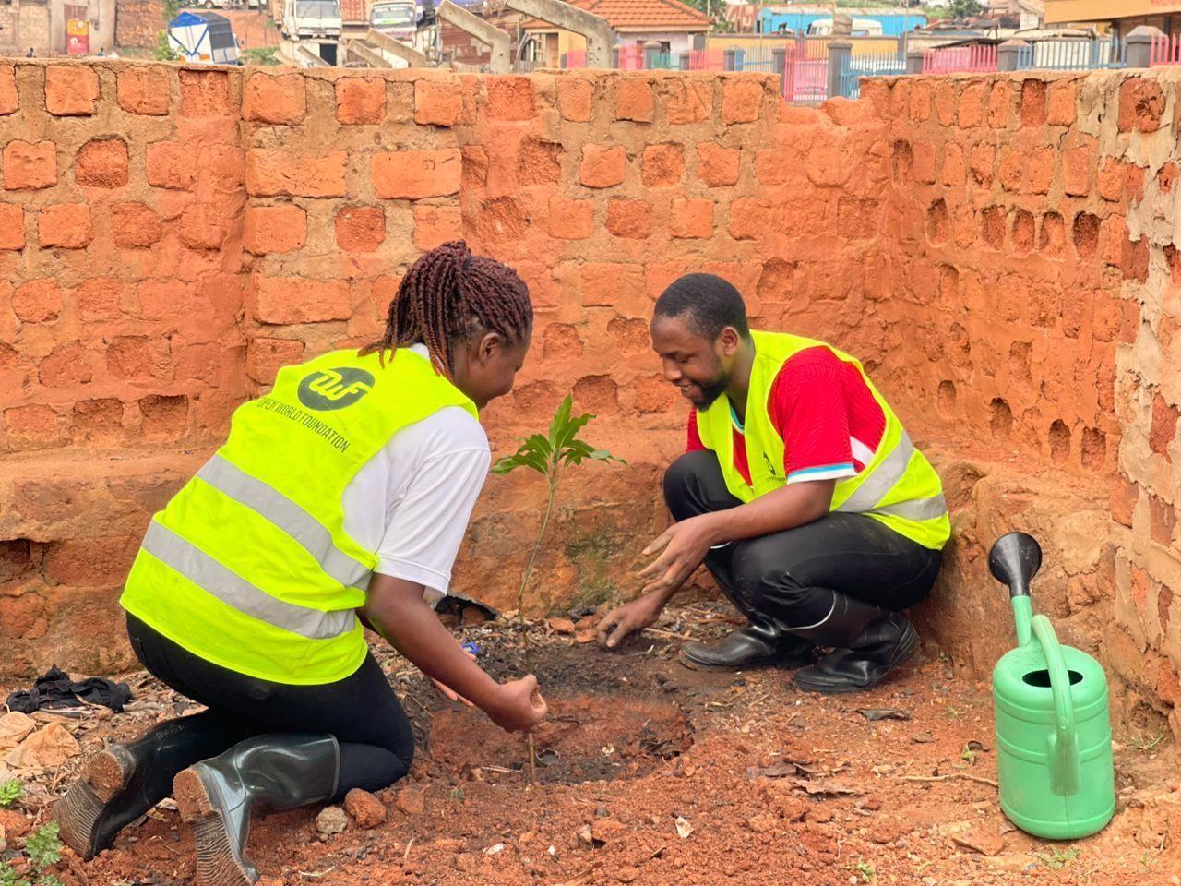

SITUATION ANALYSIS
This chapter presents an analysis of the current context within which OWF operates in the macro and micro spectrum, while identifying existing opportunities to inform the strategic priorities for the 2026-2030 period. The section also conducts a problem analysis to inform prioritizing of interventions for the strategic and programming Theory of Change.

3.1 Macro context analysis
The macro-economic environmental scan has been carried out using a PESTLE analysis as summarized in Table 2 below.

Table 1 PESTLE Analysis
PESTLE | Finding | Implication
Political | - Relative political stability with periodic tensions  - The shrinking civic space, due to suspensions alongside significant global donor cuts and funding contractions.  - The recently passed Sovereignty Act, introducing stricter controls over foreign influence and civil society engagement  - Uganda is still home to several refugees that require support | - Periodic tensions and restrictions on assembly may require OWF to maintain a strictly humanitarian, non-political stance.  - Service delivery gaps from declining humanitarian actors  - Increased need for diversification of funding  - Focus of should be on building government partnerships; and supporting refugee programming
Economic | - Resilient growth amid pressures, for example increase in Gross Domestic Product driven by agriculture, services, exports (e.g. coffee), and public investment | - Opportunities exist in enhancing access of vulnerable groups to sustainable livelihoods and income Generating Activities (IGAs)
Social | - The population is youth- heavy with a high growth rate (75% below 35 years of age)  - Multidimensional poverty and food insecurity still affect millions of people with more vulnerable groups having higher risks  - Increase on the focus on mental health tracking both nationally and globally with high rates recorded | - Prioritization of young people as a key demographic, given their composition within the population  - Focus on the root causes of poverty, with a key emphasis on vulnerable groups such as youth, women, refugees, and children  - Incorporation of mental health initiatives, particularly for young people to aid in risk reduction
Technological | - High Digital growth (Phone ownership, mobile money use/fintech expanding, ICT investments improving etc.)  - Infrastructures are limited, costs are high and adoption is slow by small businesses and rural groups  - Growth in Artificial Intelligence use | - Leverage mobile tools for outreach/education (e.g., digital skills training for youth).  - Identify and implement partnership opportunities in ICT.  - Need for awareness on AI, while leveraging the opportunities it presents for young people
Legal | - Restrictive NGO environment: NGO Act 2016 amendments allow suspension.  - Strict regulation: Annual NGO Bureau renewal fees, permits, reporting deadlines, and potential for unannounced inspections.  - Bureaucratic hurdles for registration/funding exist | - Operational risks are present within the operational environment thus the need to maintain transparency and focus on alignment with national objectives, policies and frameworks  - Ensure legal compliance with existing regulations within the country
Environmental | - Deterioration in the state environment due to poor practices in management  - Erratic rainfall, droughts/floods, deforestation and land degradation  - Climate shocks which exacerbate poverty/refugee vulnerabilities | - Integrate resilience (e.g., climate-smart agriculture, eco-friendly technologies, nutrition in food-insecure zones) into programming  - Green Humanitarian Action that ensures that all interventions are not harmful to the environment

Informed by this PESTLE Analysis, the OWF 2026-2030 strategy will prioritize youth-focused programming aimed at tackling the root cause of poverty, diversified resource mobilization and government partnerships to navigate the restrictive civic and legal environment, and climate resilient programming that protects both vulnerable communities and the environment

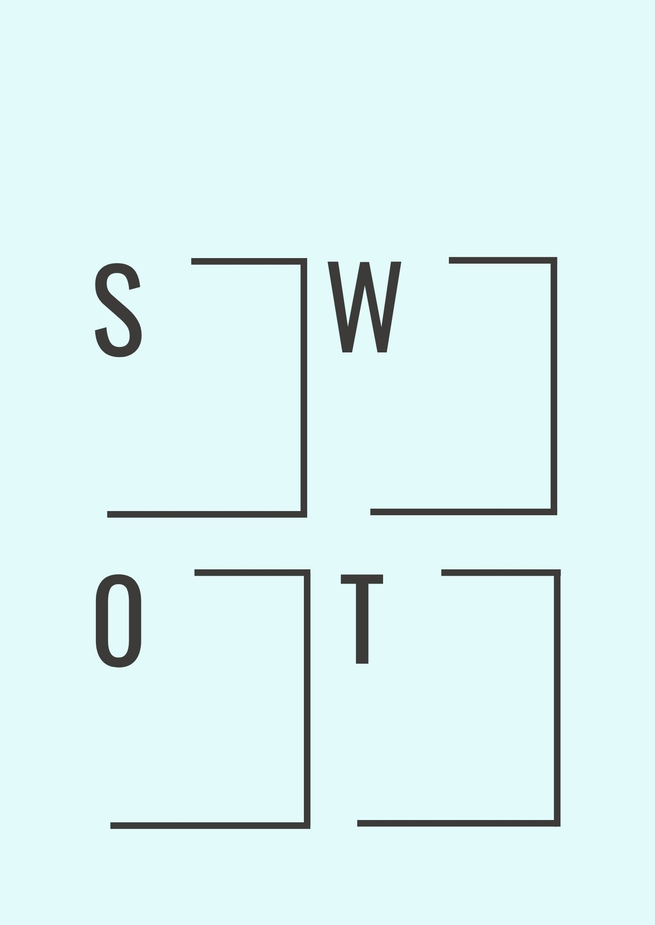
3.2 Micro context analysis
A sound strategic direction is only as viable as the organization's capacity to execute it. The strategic direction identified through the PESTLE must thus be weighed against OWF's internal realities; what the organization does well, where it falls short, what it can capitalize on, and what could undermine its progress. As such, the organization's strengths and weaknesses have been analyzed against the external opportunities and threats in Uganda's operating environment using a SWOT analysis, thereby providing a grounded basis for strategic decision-making and resource allocation.

THREATS – Mitigate
- Increasing donor cuts by international funding partners
- Competition among NGOs for the limited available funding
- Stricter controls over foreign influence (The national Sovereignty Act 2026)
- Global health security risks (e.g., COVID-19)
WEAKNESSES - Address
- Limited available resource basket
- Limited partnerships with government, other CSOs in Uganda and diversified donors
- OWF is still new in Uganda without adequate experience
in the Non-profit landscape
OPPORTUNITIES - Exploit

- Shrinking civic space, leaving a gap in service delivery
- Existing multisectoral needs and vulnerabilities
- Existing capacity for local and diaspora resource mobilization
- Growth in technology, Artificial Intelligence (AI) and media use
STRENGTHS - Leverage
- Presence of a partner willing to provide seed funding and operational workspace with equipped resources, volunteers and knowledge sharing opportunities
- Existing collaborations with broad youth networks
- Existing knowledge and experience in the context of operation

3.3 Problem analysis
What is the root causes of this?
The intergenerational Poverty trap that locks young people in a never-ending vicious cycle of unstable livelihoods, poor health, and inadequate education.
Uganda has up to 75% of its population below the age of 35 years, making it one of the youngest countries in the world. Economically, this could prove to be one of the greatest advantages for the country – but only if the young people remain healthy, receive the necessary education support and thrive in safe and sustainable communities that guarantee their futures.
Reality, however, falls short of this promise. Despite ongoing efforts by the Government of Uganda (GoU) and humanitarian partners, the National Population and Housing Census 2024 (NPHC) reported about half (50.9%) of youth aged 18-30 as not in Employment, Education or Training -underscoring the persistent barriers to unlocking this demographic dividend.
Even for those that find work, the burden remains heavy: with an age dependency ratio reported at 83.8, meaning employed youth carry the weight of multiple dependents, leaving little room for investment in their own growth.
The combined effect of exclusion from opportunity and dependency traps young people in a state of unrealized potential, and the consequences are visible and destructive: drug and alcohol abuse, transactional sex, early and forced marriage, risky oversee migration and trafficking, suicide and worsening mental health among others.

Unstable Livelihoods
- Unemployment rate at 12.3% (greater than global average of 4.9%)
- More than half (50.9%) of youth have been looking for work or trying to start a business for over one year
- 83% of emigrants moved to look for jobs with over half moving to Asia
Poor Health
- 54% of Households are food secure
- One in every ten people (>=10yrs) experienced some form of probable general psychological distress
- 43.6% of households with improved toilets/ latrines and 91.6% practiced improper solid waste disposal
Inadequate Education
- 41.6% children attending Early Childhood Education (ECE), 75.2% Primary and 62.0% secondary.
- 59.9% of 6-year-old children had not started their first year of primary
- New revision of Uganda curriculum; A shift from Competency-Based Curriculum (CBC) for lower secondary in Uganda, leaving low adopters in rural schools behind.
(Source: NPHC, UBOS 2024)

3.3.1 The Nexus of the Problem – The Intergenerational Poverty Trap
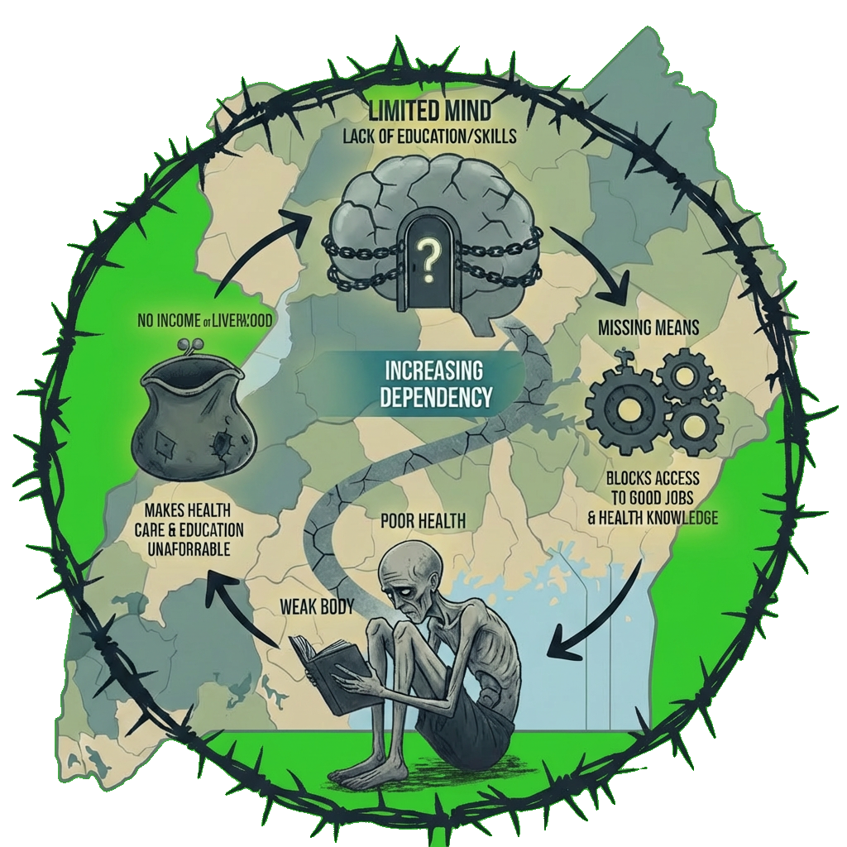
As demonstrated by the problem analysis in Section 3.3, poverty is the root cause - a structural and intergenerational trap that causes a vicious cycle of failures in health, education, and livelihoods. In this section of the strategic plan, we explain this cycle, breaking down how each sector traps the youth and how they interconnect to prolong poverty across generations.

- Without stable income young people struggle to afford healthcare or quality education.
- Without education, they lack knowledge on health protection and miss out on skills to access decent jobs that give stable incomes.
- Without health, they cannot attend school or work regularly and productively

More and more young people therefore fall out of productive engagement, forcing them to depend on their other family members for longer periods. But these families are already struggling, so the burden keeps growing, pushing everyone deeper into poverty that passes from one generation to the next. It is against this background that OWF will position itself to provide HELP (Health, Education and Livelihood Projects) in the strategic period 2026-2030 with the following goal.
Figure 2 Cycle of poverty (OWF problem analysis)
Goal: Youth (particularly those trapped in cycles of poverty and dependency) can break free, become self-reliant, and reach their full potential.
KEY FACT: Health, education, and livelihood projects will mean little if young people inherit a damaged environment. We therefore commit to environmental sustainability in every intervention, securing a livable future for generations to come.

STRATEGIC DIRECTION (2026-2030)

4.1 Overview
This chapter of the strategic plan focuses on the key direction for Open World Foundation within the period 2026-2030, for both internal effectiveness and efficiency, as well sustainable programming in line with the problem analysis.

4.2 Vision
A world where every young person has the health, education, and livelihood to reach their full potential.

4.3 Mission
Empowering youth to break free from poverty through community-led solutions in health, education, and livelihoods to enable them to become self-reliant and stay there.

4.4 Theory of Change (ToC)
The Theory of Change acknowledges that vulnerable youth can escape intergenerational poverty through various interconnected pathways rather than a fixed order. Three main pillars emerged from the problem analysis: Education (Mind), Health (Body), and Livelihood (Means) (Figure 2). These three pillars support one another through mutual relationships, each contributing to one another, thereby creating a positive cycle. For example, knowledge from education leads to better health practices. Healthy students tend to stay in school longer and acquire more skills. Additionally, healthy youth are more productive at work, and stable incomes provide them with the means and knowledge to gain more skills. Skills and knowledge for work feed back into educational goals, while earnings help fund health services, and the cycle continues. Each pillar is backed by clear interventions that put these relationships into action
The essence of this network is that young people stuck in poverty can break free, become independent, and reach their full potential. This change does not require every participant to experience all three pillars in a specific sequence. Instead, the system is set up so that engaging in any area has positive effects that strengthen the others, allowing youth to find the best path out of vulnerability for themselves.
The entire system is situated within the context of technology, environmental sustainability, and policy coordination. It relies on strategic partnerships and networks, ongoing capacity building, and advocacy based on evidence. These are essential conditions that allow the three pillars to work as an integrated system rather than independent interventions. The approaches remain local, operating at the household level and driven by community-led processes. This ensures that the positive cycle is rooted in the realities of the communities served rather than imposed from outside.
Figure 3 Theory of Change
Vulnerable youth locked in intergenerational Poverty trap gets HELP (Health, Education and Livelihood Project)

Physical and psychosocial health services and health education
Good Water, Sanitation and Hygiene (WASH) practices at Household
(Mind Pillar: Education)
Improved access to, completion of and transition rates in quality
education
(Body Pillar: Health
Improved health and well-being
Supportive and adaptive learning environments
Community and parental participation in education
Education access barriers removed

Knowledge improves health practices

Healthy Learners Stay in School

IMPACT
Young people trapped in cycles of poverty and dependency can break free, become sustainably self-reliant, and reach their full potential

Good Nutrition and feeding practices within the household
Skills and knowledge for work
Resources to access health

Resources to obtain more skills
Healthy Youth is active in work

Context: Technology

Environmental sustainability

(Means Pillar: Livelihood
Secure and Sustainable
Incomes
Multi-sectoral skills for livelihood engagement

Capital - Micro-enterprise or venture support packages
Employment and career opportunities
Strategic Enablers: Partnerships & Networks| Capacity building| Advocacy || Approaches: Localization | Household level | Community-led

Assumptions of the ToC
The following are key assumptions of the ToC for implementation with stakeholders for the strategic period 2026-2030.
- Political and security stability in Uganda and the region will be maintained, allowing for uninterrupted program implementation.
- Improvements in one pillar (e.g., health) will not be undermined by deterioration in another (e.g., livelihood loss forcing school withdrawal), meaning households can manage trade-offs across the three domains.
- The required funding for the full strategic planning period will be secured and disbursed on schedule as per the commitments of OWF.
- There will be no major external shocks during the strategic period (natural disaster, disease outbreaks, large-scale conflict, or abrupt policy change) that will disrupt implementation timelines and approaches to be used,
- Target beneficiaries will be reachable and willing to participate in activities at expected uptake rates.
- OWF will secure all relevant Key implementing staff and partners, and these will remain available and maintain required skills throughout the strategic period.
- The local economy will generate sufficient demand for skilled youth labor and micro-enterprise products, ensuring that livelihood gains are sustainable
- Targeted households will prioritize investment in health and education over immediate consumption needs, and will not engage children in labor activities
- Youth enrolled in multi-sectoral skills programs and quality education opportunities will complete the full cycle, with dropout rates remaining below 15%.
- Community and parental participation interventions will successfully shift gendered social norms that currently restrict girls' mobility, school attendance beyond puberty, and participation in mixed-gender skills training.
- Local markets and community leadership will accept youth (especially females) as legitimate economic actors and players
- District-level education, health, and labor policies will remain aligned with OWF's localization and household-level approaches, and local government will actively facilitate rather than obstruct community-led processes.

4.5.OWF Strategic Direction 2026-2030

4.5.1 Strategy Map
In line with the ToC, the following strategic directions have been identified for implementation by OWF in the strategic period 2026-2030. This section summarizes key actions under each of the three pillars Education, Health, and Livelihood recognizing that progress in any one area strengthens the others, and that youth will enter and move through the system at different points to increase and sustain their self-reliance.
External facing strategies
Internal Enablers

PILLARS
HEALTH
INSTITUTIONAL CAPACITY
EDUCATION
LIVELIHOOD

STRATEGIC OBJECTIVES
Functional, compliant, and credible organizational framework will be established within OWF
Secure and Sustainable Incomes in place
Improved access to, completion of and transition rates in quality education
Improved health and well-being

- Access to physical and psychosocial health services and health education created
- Water, Sanitation and Hygiene (WASH) improved at household level
- Nutrition and Feeding practices Strengthened

Strategic Actions
Figure 4 OWF Strategy Map
- Strengthen Organizational Capacity (HR, Finance, Governance, and Operations)
- Sustainable Resource mobilization channels established
- Strategic partnerships and networks strengthened
- Micro-enterprise or venture support packages provided and supported
- Linkages to employment and career opportunities created
- Multi-sectoral skills provided
STRATEGIES
- Demographic barriers to education access removed
- Community and parental participation in education strengthened
- Supportive and adaptive learning environments created

4.5.2 Strategic Target Groups
The strategy map clearly establishes strategic directions across the three pillars. However, it is also essential that this plan defines for whom these interventions are designed. This section therefore identifies the specific populations that OWF will reach, prioritize, and adapt its programming for, ensuring that the ToC is grounded for the most affected groups.
A. Location of Implementation
Figure 5 Targeted OWF locations for the period 2026-2030
Northern Region
Karamoja Sub-region

Western Region
Rwenzori Sub-region

Central Region
Urban Youth

Eastern Region
Busoga Sub-region

Open World Foundation selected four priority sub-regions based on consistently low livelihood, education and health indicators. For instance, Karamoja Sub-region (Northern) records the highest poverty headcount in Uganda at 74.2%, with 88.5% of households falling within the poorest bottom. Additionally, Busoga Sub-region (Eastern) is home to approximately 840,700 people living in absolute poverty, contributing 12% of Uganda's total poor population, with over half of households in the poorest 40%. The region also suffers health challenges such as jigger infestations. Rwenzori Sub-region (Western) reflects the Western region's broader challenges, where poverty reduction has been uneven and health indicators remain weak relative to the national average. The region has for the previous years also sufferred from conflict and unrests that have hampered overall development.
Kampala (Central) was selected for two reasons: it hosts the highest concentration of urban youth facing unemployment and rising urban poverty, and it serves as the organizational headquarters enabling direct oversight and coordination.

A. Project Beneficiary Groups
Table 2 Targeted beneficiary groups for OWF interventions
Primary Beneficiaries | Target
- Youth-headed households and young people with dependents. We acknowledge that this group often lacks access to quality education, stable health services, and sustainable job opportunities. They take on adult responsibilities too soon and work without the safety nets that family structures usually provide. Their challenges stem from interrupted schooling, early parenthood, and the immediate need to earn income for dependent siblings or their own children.  Selection Criteria: Urban and Rural Youth aged 18–35 heading households and/ or with dependents, living in poverty, with interrupted education, excluded from livelihoods, and facing health or social barriers.  - OWF will also target 5 schools (Primary seven, and secondary school). These institutions reach adolescents within youth-headed households, providing a dual channel: direct support to students who might otherwise drop out due to cost, health barriers, or household disruption; and a platform for school-based interventions. Schools will become extensions of the household approach, ensuring that children in vulnerable families receive consistent support across both environments.  Selection Criteria: Schools will be selected based on their proximity to target communities, high enrollment of vulnerable learners, and readiness to collaborate on nutrition, health, and literacy interventions that amplify household-level gains. | 9000 primary beneficiaries  Health  1000 youth headed HHs  5000 girls  Education  5 schools  1000 learners  10 teachers  Livelihood  1500 youth headed HHs  10 employers/ private sector actors

Secondary Beneficiaries | Target
We recognize that even when the youth household head is empowered, the presence of dependents still poses a significant risk of pushing the entire household back into poverty. As such, all household participants are ensuring that household vulnerabilities are addressed. Secondary beneficiaries will include parents, guardians, siblings, the elderly and other dependents.  Selection Criteria: All persons within the household or immediate community who influence or are affected by the primary beneficiary's trajectory, selected on the basis of their direct caregiving role, and co-residence with the primary beneficiary. | 11000 secondary beneficiaries  Approximately 5 additional household members for each youth-headed household
Disaggregation of Households
60% Female and 40% Male headed
5% of PWDs headed households
5% Refugee headed households

B. Partners and Target Groups
OWF recognizes that the sustainable development of vulnerable youth depends on deliberate collaboration with partners who contribute complementary resources, expertise, and credibility within the three-pillar model. Therefore, we will collaborate with government Ministries, Departments, and Agencies (MDAs), including District Local Governments (DLGs) in our areas of implementation. We will also engage other Civil Society Organizations and NGOs to promote coherence, facilitate learning, and build partnerships.
Private-sector actors and industry associations will be involved in reviewing curricula, training youth, providing apprenticeship opportunities, and supporting entry into wage jobs or into supply chains. Partnerships will also be established with key stakeholders such as schools, health facilities, and processors across the three pillars, and technology providers will be engaged to support in delivering digital skills and mobile-based health solutions
To support continuous learning, OWF will engage research institutions to generate evidence and inform adaptive management. OWF will also actively participate in stakeholder working groups, technical meetings, and networks related to livelihoods, health, education, and M&E to foster ongoing learning. To continuously facilitate effective partnership management and coordination, OWF projects will conduct comprehensive stakeholder mapping to identify collaboration opportunities, build strategic partnerships that enhance impact, promote inclusive representation across stakeholder groups, and adapt programming to the changing context.

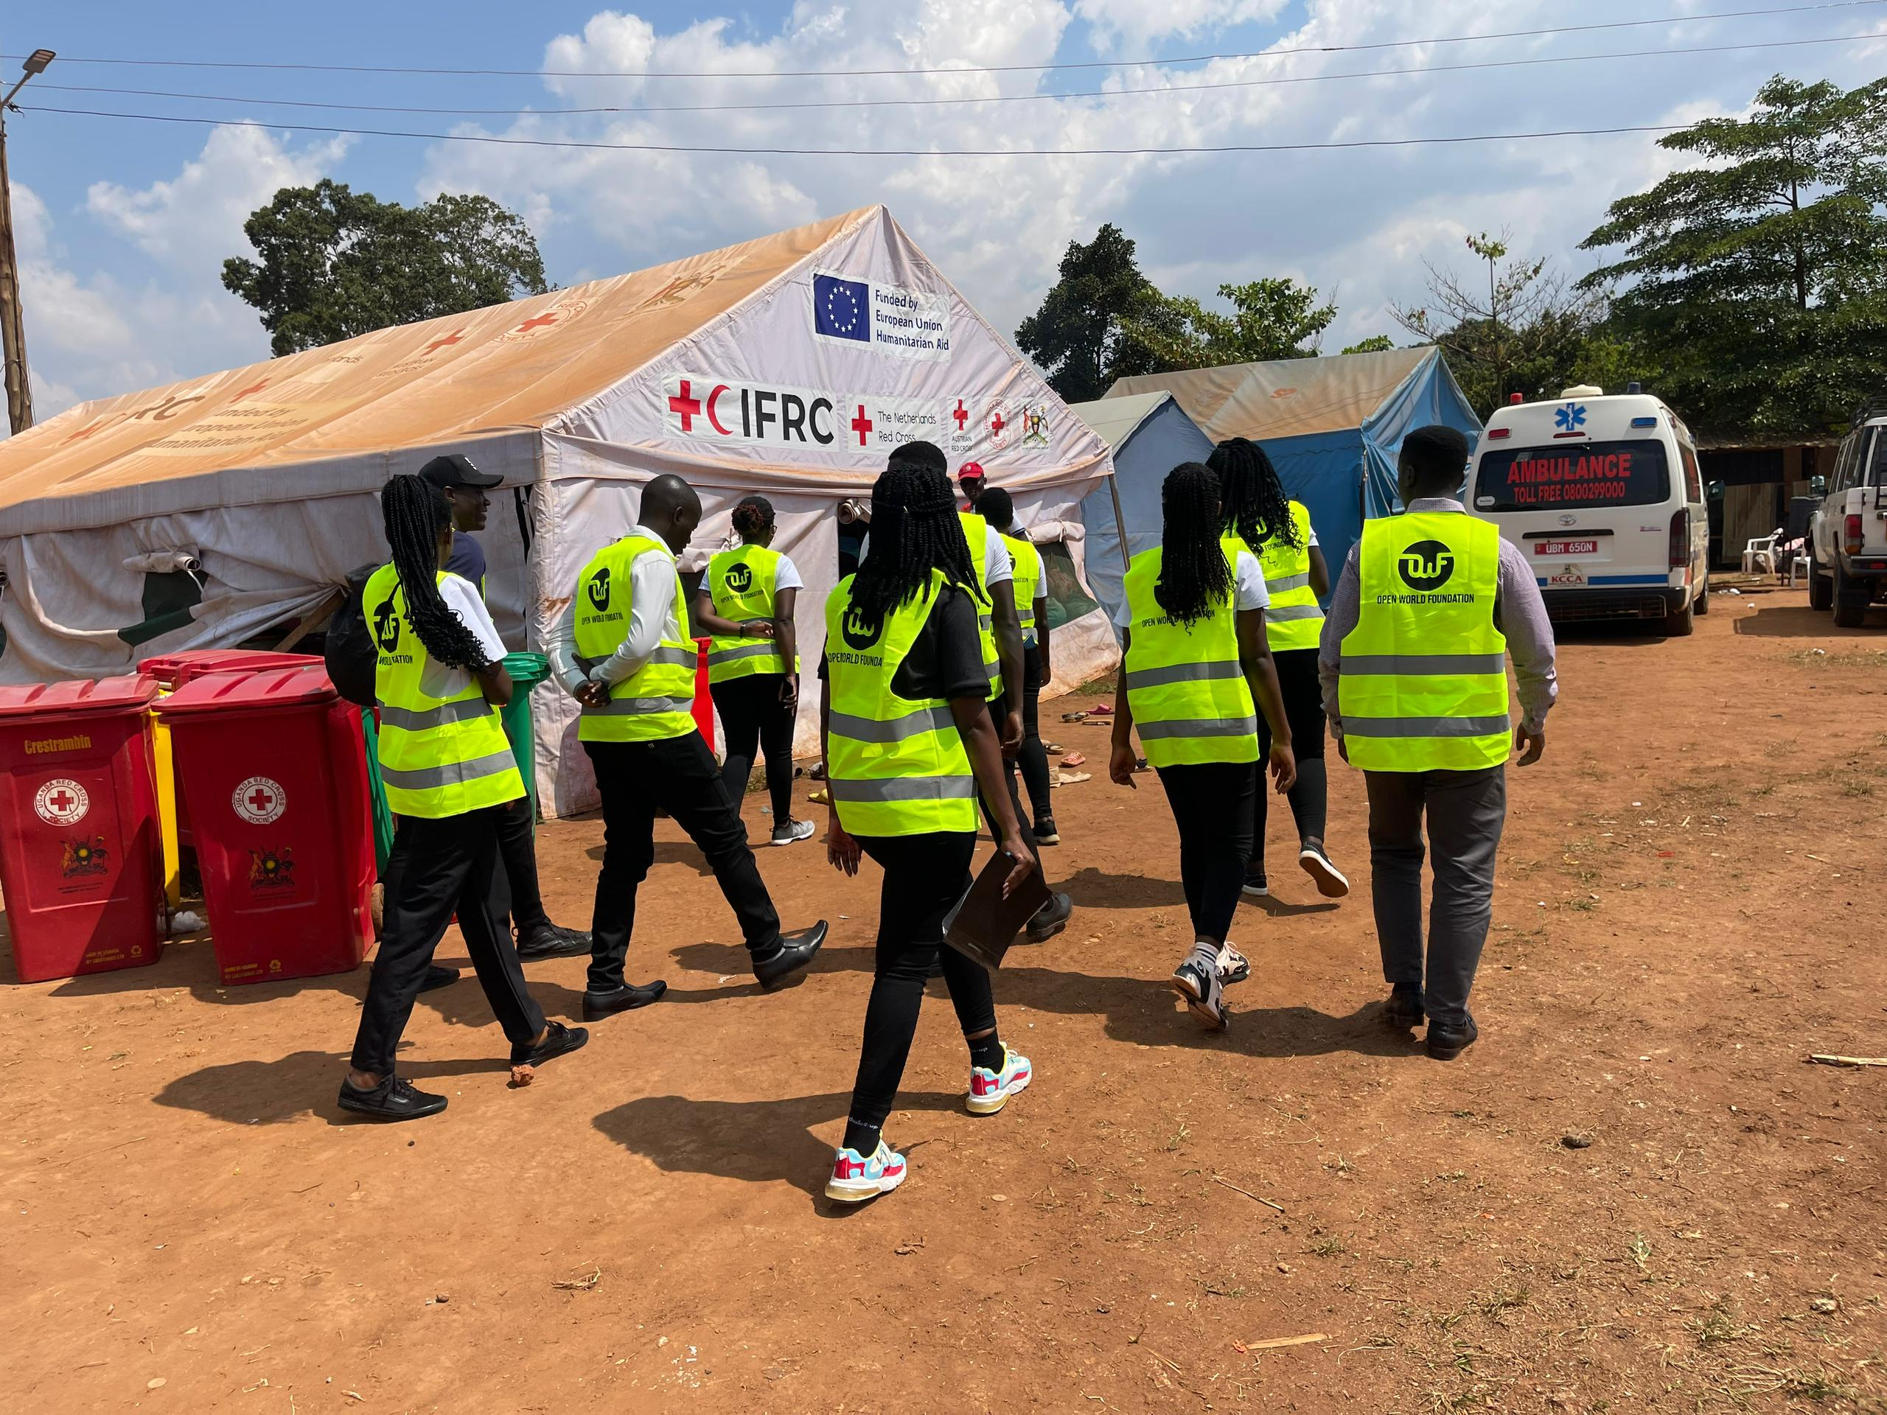

4.5.3 Strategic Objectives, outputs and strategic Actions
In line with the strategy map (4.5.1) and the targeted beneficiaries (4.5.2), this section of the strategic plan defines the specific objectives, measurable outputs, and priority actions that will guide Open World Foundation's implementation over the 2026–2030 period. The section is organized according to the three pillars; Health, Education and Livelihood, and specifies strategic objectives and actions for each. The section is concluded by a summary matrix of the strategic direction for OWF implementation 2026-2030.

PILLAR 1: HEALTH
Strategic Objective: By 2030, 400 vulnerable youth-headed households experience improved health and well-being
This pillar focuses on ensuring vulnerable households and individuals can easily fulfil their physical and psychosocial needs, because healthy people are capable of participating fully in education, work, and impactful activities within their communities. To achieve this objective, OWF will focus on increasing access to health services, and enhancing community and household health and nutrition practices, as shown discussed below.

Strategy 1.1: Access to physical and psychosocial health services and health education created for 400 vulnerable youth headed households
OWF will enhance access to health services by designing and rolling out an integrated community health and psychosocial support program that targets vulnerable households, schools, and underserved communities. The program will span medical and psychosocial health outreaches including screening, basic treatment, counselling, referrals, and follow-up for vulnerable community members, as well as health promotion and behavior-change campaigns delivered through community dialogues, radio, social media, and school-based awareness sessions. Mental health will be addressed through community and school-based awareness initiatives, including cycling club activities, peer support sessions, and referral linkages, with comprehensive coverage of disease prevention, reproductive health, and trauma-informed care. These initiatives will aid in maximizing access by overcoming barriers such as distance, cost, and knowledge gaps.

Strategy 1.2: Water, Sanitation and Hygiene (WASH) improved for 400 youth headed households and 2000 girls
OWF believes that even when a person is healthy, his or her environment and health-seeking behaviors still present a risk of re-infection. As such, the strategic period will support targeted beneficiaries to achieve improved household and community hygiene and positive health-seeking behaviors that can ensure sustainability in the health status they have achieved.

This will be done through hygiene promotion sessions and household demonstrations for 250 vulnerable households on key hygiene behaviors, including handwashing, sanitation, safe water handling, and environmental cleanliness. OWF will also reach up to 1000 girls with dignity kits and menstrual hygiene management items. This will ensure that menstrual health needs do not become a barrier to school attendance, dignity, and active participation in community life.

Strategy 1.3: Nutrition and feeding practices strengthened for 400 vulnerable youth-headed households
The strategic period will also involve the support of Maternal, Infant, Young Child, and Adolescent Nutrition (MIYCAN) in households to ensure that the right food is being eaten, in the right quantity, and that these are properly preserved to support long-term health benefits among the households that OWF serves. This will be done through the development and implementation of a community nutrition program focusing on nutrition education, household counselling, screening and referral for malnourished children and vulnerable households.

OWF will also establish and support nutrition clubs in 10 schools to promote healthy feeding practices, school gardens, and peer-led nutrition education, while also providing targeted food and nutrition support to 250 vulnerable households, linked to nutrition counselling and household food security planning.

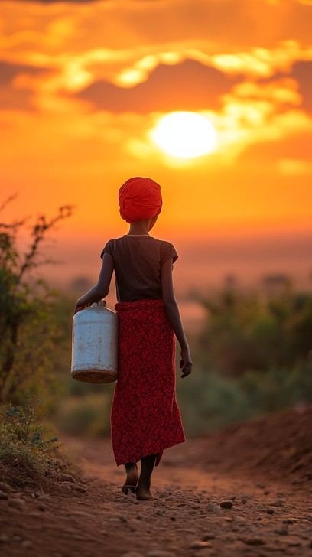
Figure 6 A young lady moving to fetch water

PILLAR 2: EDUCATION
Strategic Objective: By 2030, access to quality education is improved for 2000 learners and the completion and transition rates within 5 primary and secondary schools.
This pillar focuses on ensuring that young people get the knowledge required to participate in their communities. Educated people are powerful agents of change, not just for themselves, but also the wider community. They gain the tools required to start up sustainable livelihoods, and the knowledge needed for them to maintain and promote healthy behaviors. Education therefore has a multiplier effect on incomes, nutrition, and socialization, among others. To achieve this objective, OWF will focus on removing education barriers, and ensuring that the surrounding communities and people are supportive, as represented in figure 7 below.
Strategy 2.1 Demographic barriers to education access removed for 2000 vulnerable students
Among the underserved and unserved population of Uganda, several demographic barriers such as gender norms, extreme poverty, disability-related exclusion, language challenges, distance, and absence of required scholastic materials continue to limit equitable education outcomes. OWF's strategy is to map out these barriers, and form targeted solutions to address them such that access to education is strengthened. This will be done through among others, the provision of educational scholarships and retention support to 25 vulnerable students, including school fees, mentorship, and progress monitoring, as well as the distribution of scholastic materials to 1,000 vulnerable learners to improve attendance, participation, and school completion.

Strategy 2.2 Community and parental participation in education strengthened across 5 schools
This strategy aims to strengthen ownership and sustainability of education initiatives that will consequently improve retention and create supportive environments for learners. The strategy will ensure that children are surrounded by mentors from the community in which they live. OWF will train 10 teachers in storytelling, creative writing, and learner-centred literacy approaches that foster critical thinking, imagination, and active engagement in the classroom. OWF will also establish storytelling and reading clubs in 5 schools, with active participation of teachers, parents, and community volunteers, creating supportive spaces for learners.

Strategy 2.3 Supportive and adaptive learning environments created across 5 schools
We recognize emerging trends such as the ongoing revisions to the education curriculum, and that there are both slow and fast adopters. OWF will facilitate school-community dialogue meetings to promote parental involvement in learner attendance, retention, safety, and transition. OWF will also compile stories developed through school writing clubs, edit, design, and print 5 child-friendly story booklets that promote literacy, creativity, inclusion, and positive values among learners.
PILLAR 3: LIVELIHOOD
Strategic Objective: By 2030, 1000 youth headed households have secure and Sustainable Incomes
Youth with secure livelihoods have a higher chance of breaking out of poverty, as they have the necessary incomes to access other services within the community. This financial stability is not only seen as a route to essential healthcare, quality education, and nutritious food, but also reduces their vulnerability to shocks such as illness, unemployment, or economic downturns. Ultimately, empowering youth for improved household wellbeing.
Strategy 3.1 Micro-enterprise or venture support packages provided and supported to 500 vulnerable youth
This strategy focuses on the provision of household-selected and managed livelihood enterprises that can uplift economically vulnerable individuals and households. It is anticipated that this strategy will increase income sources within the household so as to minimize the dependency rate, while also allowing youth to have resources to access various education and health services available in their communities.
This will be done through training 200 vulnerable youths in social entrepreneurship, business planning, financial literacy, savings, and market assessment, and providing startup capital and enterprise kits to 50 vulnerable youths to translate their skills into viable, income-generating activities. We will therefore take the targeted households through the entire business planning, management and marketing process.
Strategy 3.2 Linkages to employment and career opportunities created for 1000 vulnerable youths
In the formal sector, many young people fail to transition into employment and other career activities. Similarly, micro enterprises established in the informal sector also suffer from limited market opportunities. This strategy will therefore link enterprising businesses and individuals with consumers, while enabling young and talented youth to access various employment and career opportunities. This will be done through establishing partnerships with 10 employers, including vocational institutions, financial service providers, and business networks, to create internship, job placement, and mentorship opportunities for vulnerable youths. OWF will also conduct career guidance, job readiness, and financial literacy sessions for 200 vulnerable youths, equipping them with the skills and confidence to navigate both formal employment pathways and informal enterprise development.
Strategy 3.3 Multi-sectoral skills provided to 500 vulnerable youth
This strategic period will include the extension of comprehensive training opportunities to various youth-led enterprises. Training will be conducted for 100 vulnerable youths in market-driven vocational and life skills, including agribusiness, tailoring, catering, digital skills, financial literacy, and business management. OWF will also link 100 trained youths to mentorship and skills certification opportunities through local businesses, training institutions, and private sector partners, ensuring that acquired competencies are validated, refined, and aligned with market demands.

PILLAR 4: INSTITUTIONAL CAPACITY
Strategic Objective: By 2030, Functional, compliant, and credible organizational framework will be established within OWF
In line with our vision, OWF will ensure the right staff, structures, and processes are in place to implement the projects that the community and funding partners trust us with. We shall prioritize the establishment of essential internal infrastructure needed to deliver high-quality, sustainable community programs so as to enhance our accountability mechanisms.
Strategy 4.1 Strengthened Organizational Capacity (HR, Finance, Governance, and Operations)
OWF is a young organization that recognizes that projects cannot be efficiently and effectively implemented without solid and air-tight structures in place. As such, this strategy focuses on strengthening the internal systems, processes, and structures to ensure efficient, transparent, and professional management. OWF will ensure continuous and full legal compliance and that all required systems and documents are in place. This will be done through developing, approving, and operationalizing core organizational manuals and policies, including HR, finance, Board charter, Program, M&E plan, procurement, gender, safeguarding policies, and Environmental, Health, Safety (EHS), and child protection manuals. OWF will also conduct staff and board orientation on approved policies, compliance requirements, internal controls, safeguarding, and organizational procedures, ensuring that governance and operational standards are understood, internalized, and applied across all levels of the organization.

Strategy 4.2 Sustainable Resource mobilization channels established
OWF will build diversified fundraising modalities to enhance sustainable funding for the organization. This will ensure that there is a continuous resource stream to support organizational activities as and when the need arises. This will be done through developing and implementing a resource mobilization and sustainability plan that maps multiple revenue streams while establishing clear accountability frameworks, donor reporting protocols, and risk mitigation strategies to maintain transparency and trust across all funding relationships.

Strategy 4.3 Strategic partnerships and networks strengthened
OWF notes that each of our implementation themes requires strategic partners including but not limited to the government, other NGOs and individuals as well OWF will cultivate collaborative relationships to expand reach, credibility, and opportunities. We also understand that funding partners should also be frequently engaged through informing, participating in their initiatives, and organizing other sharing opportunities. OWF will subscribe to and actively participate in relevant coalitions, networks and coordination platforms aligned to OWF’s strategy. Additionally, strategic partnerships will be developed and maintained through MOUs, joint planning meetings, referral pathways and collaborative program initiatives.

Table 3 Summary of Intervention Logic and Implementation strategies (2026-2030)
Strategic Objective | Strategies | Actions/ Activities | Responsible | Y1 | Y2 | Y3 | Y4 | Y5
PILLAR: HEALTH  1. By 2030, 400 vulnerable youth-headed households experience improved health and well-being | 1.1 Access to physical and psychosocial health services and health education created for 400vulnerable youth headed households | 1. Design and roll out an integrated community health and psychosocial support program targeting vulnerable households, schools and underserved communities. | Program Manager Health | X | X
 |  | 2. Conduct medical and psychosocial health outreaches, including screening, basic treatment, counselling, referrals and follow-up for vulnerable community members. | Program Manager Health |  |  | X | X | X
 |  | 3. Conduct health promotion and behaviour-change campaigns through community dialogues, radio, social media and school-based awareness sessions. | Program Manager Health IT, Communication and digital media manager | X | X | X | X | X
 |  | 4. Conduct community and school-based mental health awareness initiatives, including cycling club activities, peer support sessions and referral linkages. | Program Manager Health |  | X | X | X | X
 | 1.2 Water Sanitation and Hygiene (WASH) improved for 400youth headed households and 1000 girls | 1. Conduct hygiene promotion sessions and household demonstrations for 400 vulnerable households on key hygiene behaviors i.e. handwashing, sanitation, safe water handling and environmental cleanliness. | Program Manager Health |  | X | X | X | X
 |  | 2.Distribute dignity kits and menstrual hygiene management items to 2,000 girls. | Program Manager Health | X | X | X | X | X
 | 1.3 Nutrition and feeding practices strengthened among vulnerable households | 1. Develop and implement a community nutrition program focusing on nutrition education, household counselling, screening and referral for malnourished children and vulnerable households. | Program Manager Health |  | X | X
 |  | 2. Establish and support nutrition clubs in 10 schools to promote healthy feeding practices, school gardens and peer-led nutrition education. | Program manager health | X | X | X | X | X
 |  | 3. Provide targeted food and nutrition support to 400 vulnerable households, linked to nutrition counselling and household food security planning. | Program manager health |  |  | X | X | X
PILLAR: EDUCATION  2. By 2030, access to quality education is improved for 2000 learners and the completion and transition rates are strengthened within 5 primary and secondary schools. | 2.1 Demographic barriers to education access removed for 2000 vulnerable students | 1.Provide educational scholarships and retentional support to 250 vulnerable students including school fees, mentorship and progress monitoring. | Program manager education | X | X | X | X | X
 |  | 2. Distribute scholastic materials to 2000 vulnerable learners to improve attendance, participation and completion of school. | Program manager education | X | X | X | X | X
 | 2.2 Community and parental participation in education strengthened across 5 schools | 1. Train 10 teachers in storytelling, creative writing and learner-centred literacy approaches. | Program manager education | X | X | X | X | X
 |  | 2. Establish storytelling and reading clubs in 5 schools, with active participation of teachers, parents and community volunteers. | Program manager education | X | X | X | X | X
 | 2.3 Supportive and adaptive learning environments created | 1. Conduct school community dialogue meetings to promote parental involvement in learner attendance, retention, safety and transition. | Program Manager Education |  | X | X | X | X
 | 2.3 Supportive and adaptive learning environments created | 2. Compile stories developed through school writing clubs, and edit, design and print 5 child-friendly story booklets that promote literacy, creativity, inclusion and positive values among learners. | Program manager education |  | X | X | X | X
PILLAR: LIVELIHOOD  3. By 2030, 1000 youth headed households have secure and Sustainable Incomes | 3.1 Micro-enterprise or venture support packages provided and supported to 500vulnerable youth | 1.Train 300 vulnerable youths in social entrepreneurship, business planning, financial literacy, savings and market assessment. | Program manager livelihood |  | X | X | X | X
 |  | 2. Provide startup capital and enterprise kits to 200 vulnerable youths. | Program manager livelihood |  | X | X | X | X
 | 3.2 Linkages to employment and career opportunities created for 1000 vulnerable youths | 1. Establish partnerships with 10 employers, i.e. vocational institutions, financial service providers and business networks to create internship, job placement and mentorship opportunities for vulnerable youths. | Program Manager Livelihoods |  |  |  | X | X
 |  | 2.Conduct career guidance, job readiness and financial literacy sessions for 1000 vulnerable youths. | Program Manager Livelihoods. |  |  |  | X | X
 | 3.3 Multi-sectoral skills provided to 500 vulnerable youth | 1. Train 250 vulnerable youths in market-driven vocational and life skills, including agribusiness, tailoring, catering, digital skills, financial literacy and business management | Program Manager Livelihoods |  |  |  | X | X
 | 3.3 Multi-sectoral skills provided to 500 vulnerable youth | 2. Link 250 trained youths to mentorship and skills certification opportunities through local businesses, training institutions and private sector partners | Program Manager Livelihoods |  |  |  | X | X
PILLAR: INSTITUTIONAL CAPACITY  4. By 2030, Functional, compliant, and credible organizational framework will be established within OWF | 4.1 Strengthened Organizational Capacity (HR,  Finance, Governance, and Operations) | 1. Develop, approve and operationalize core organizational manuals and policies, including HR, finance, Board charter, Program, M&E plan, procurement, gender, safeguarding policies, and Environmental, Health, Safety (EHS), and child protection manuals. | Head of  Finance and Administration  Head of programs  M&E manager | X | X
 |  | Conduct staff and board orientation on approved policies, compliance requirements, internal controls, safeguarding and organizational procedures. | Head of Finance and Administration  Head of Programs  M&E Manager |  | X |  | X
 | 4.2 Sustainable Resource mobilization channels established | 1.Develop and implement a resource mobilization and sustainability plan | Resource Mobilisation and  Partnership’s lead | X | X | X | X | X
 | 4.3 Strategic partnerships and networks strengthened | 1. Subscribe to and actively participate in relevant coalitions, networks and coordination platforms aligned to OWF’s strategy | Executive Director | X | X | X | X | X
 | 4.3 Strategic partnerships and networks strengthened | 2. Develop and maintain strategic partnerships through MOUs, joint planning meetings, referral pathways and collaborative program initiatives | Executive Director  Resource Mobilisation and Partnership’s lead

4.5.4 Cross Cutting Areas
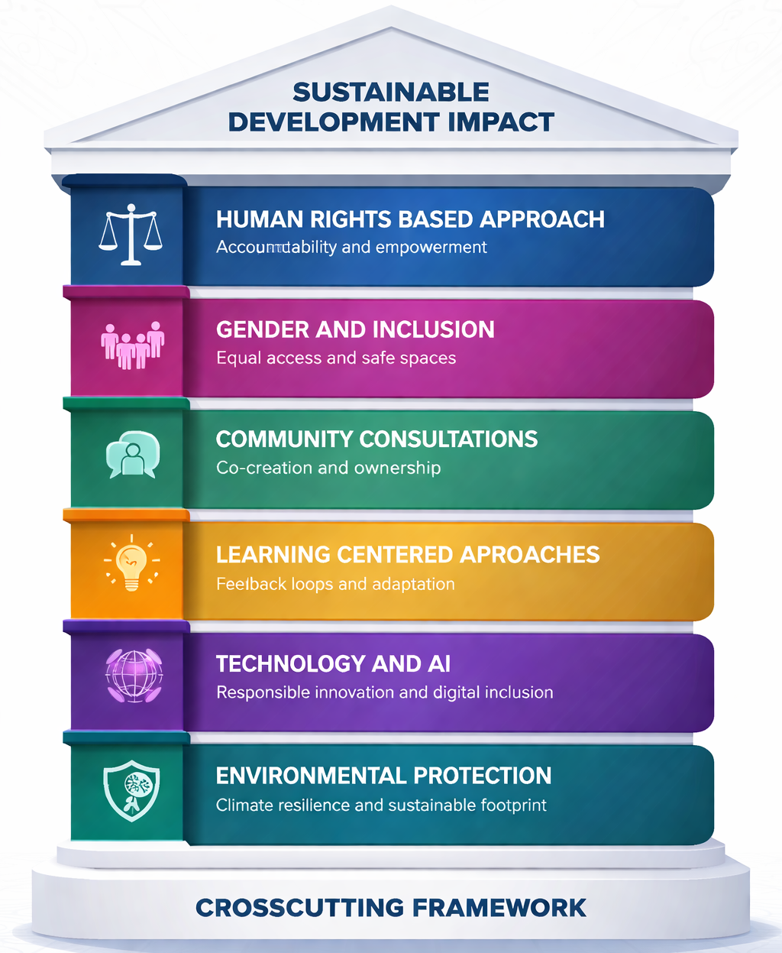
Open World Foundation will embed six crosscutting principles (Figure 7) into every programme, ensuring that all interventions are rights-based, community-driven, digitally informed, adaptively managed, inclusively designed, and environmentally responsible. We believe that this crosscutting framework will aid in achievement of sustainable impact across our strategic areas by 2030.
Figure 7 OWF Crosscutting framework
Accountability and empowerment of beneficiaries
Equal Access and Safe Spaces for Marginalised Groups
Cocreation for ownership and Sustainability
Adaptation, Feedback and Reflection
Innovation and Digitization of solutions and processes
Climate Resilience and Sustainable Footprint

IMPLEMENTATION ARRANGEMENTS
The successful translation of OWF's strategic vision into tangible outcomes for vulnerable households and communities depends on deliberate, well-structured implementation arrangements. This section outlines the operational architecture that will govern the five-year strategic period 2026–2030. These include the principles and approaches that will be capitalized upon, the institutional structure and clear lines of responsibility lines, the implementation roadmap and a comprehensive risk analysis for the strategic period.

5.1 The Guiding principles for the strategic period 2026-2030
At the heart of OWF lies 5 guiding principles that govern every aspect of our strategic plan. These values define our culture and shape our approaches in humanitarian support.
- Principle 1: Stakeholder Collaboration
We shall actively engage diverse stakeholders (including partners, beneficiaries, employees, and external groups) in planning, implementation, and review processes. This will foster inclusive dialogue, shared decision-making where appropriate, and mutual respect to build stronger, more innovative, and widely supported outcomes.
- Principle 2: Accountability to the Community
We shall prioritize transparency and responsibility toward the communities served. This will take the form of among others, regularly report progress, seeking feedback, measuring impact against community needs, and adjusting our course as needed to ensure the plan delivers genuine value and earns ongoing trust.
- Principle 3: Transparency and Integrity
We commit to open communication, honest reporting of successes and challenges, and ethical decision-making in all aspects of the plan. This builds credibility, enables informed participation from stakeholders, and ensures resources are used responsibly and equitably.
- Principle 4: Sustainability and Long-Term Impact
We shall design strategies with a focus on enduring results rather than short-term wins. Integrate environmental, social, and economic considerations to create resilient solutions that benefit future generations while adapting to changing conditions.
- Principle 5: Do No Harm
We shall ensure that all interventions are designed and implemented with careful consideration of potential unintended consequences on the communities we serve. We commit to continuous risk assessment, safeguarding of vulnerable groups including children, women, and persons with disabilities, and immediate corrective action where harm is identified or anticipated, ensuring that our presence and support leave communities stronger, not more fragile.

5.2 Phased Implementation Roadmap
OWF Implementation during this strategic period will follow a deliberate five-year phased approach that builds organizational strength before scaling programmatic reach. The OWF 2026–2030 roadmap progresses deliberately from foundation to full scale. In 2026 OWF will strengthen institutional systems, finalize the strategic plan, and launch low-cost, multi-sectoral activities with cascading results. Focus in 2027 will be on scaling implementation while diversifying resources. 2028 shows the deepening of partnerships and conducting a mid-term strategy review. In 2029, OWF achieves full operationalization with expanded networks. 2030 culminates in end-term evaluation, 90% funding and beneficiary targets reached, and structured learning for future direction.
The phased implementation roadmap is presented in figure 8 below.
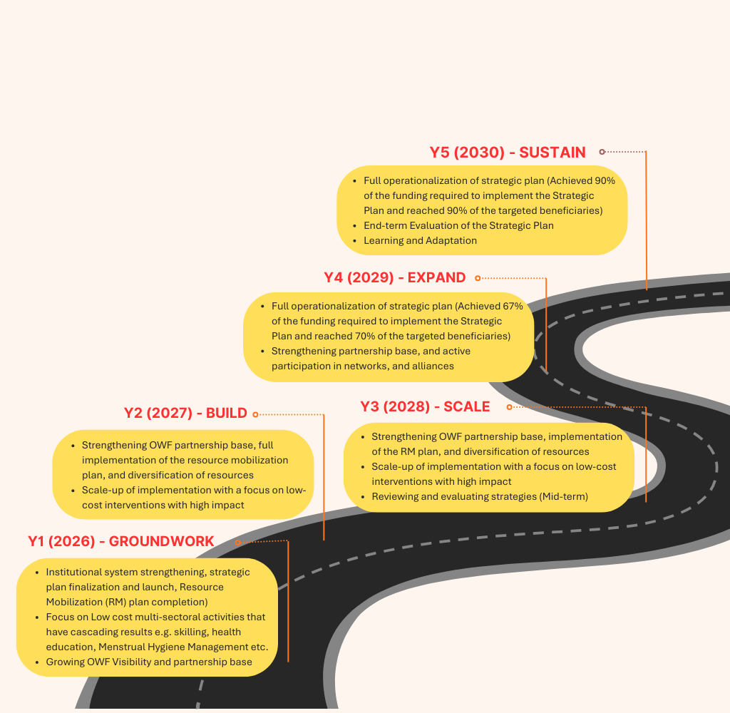
Figure 8 Implementation Roadmap for the OWF Strategic Plan

5.3 Institutional structure for implementation of the Strategic Plan

The effective implementation of the OWF Strategic Plan 2026–2030 will requires a clearly defined institutional structure that aligns human resources with strategic priorities, ensures accountability across all levels, and enables seamless coordination between governance and operations. Recognizing that organizational capacity must grow in tandem with programmatic ambition, this section presents the proposed organogram that will guide staffing, supervision, and service delivery.

This governance structure (Figure 5) is designed to balance operational autonomy with institutional accountability, ensuring that Open World Foundation remains responsive to community needs while maintaining the highest standards of transparency and organizational integrity.

Head of Programmes
(Filled)

DREW FEIG
Project Manager
Education
(PME)
(Vacant)

OFFICE MANAGER
External
Board of Directors
Executive Director
(Filled)

Legal Consultant
Auditor
Office Support Staff
(Filled)

Figure 9 Organogram to implement the strategic plan
Media,
Communications and Partnerships Officer
(Filled)

Administrator (Vacant)

Procurement officer (Filled)

Information Technology Manager
(Vacant)

Human Resource Manager (HRM)
(Filled)

M&E officer
(Vacant)

Accountants
(Vacant)

Data officer
(Vacant)

Project officer
(Vacant)

Project officer
(Filled)

Project officer
(Filled)

Head of Partnerships & Resource Mobilization
(Vacant)

Head of Finance and Administration
(Filled)

Procurement & Supply Chain Manager
(Vacant)

Finance Manager (FM)
(Vacant)

Monitoring and Evaluation (M&E) Manager
(Filled)

Project Manager
Health
(PMH)
(Vacant)

Project Manager
Livelihood
(PML)
(Vacant)

The organogram (Figure 9) establishes a three-tier governance and management hierarchy. At the apex, the Board of Directors provides strategic oversight whilst ensuring accountability, strategic alignment, and evidence-informed decision-making.
At the helm of OWF's management sits the ED, whose overall role is to ensure that the outlined strategies are implemented and that OWF interventions reach the targeted groups. The ED will oversee the day-to-day operations of the organisation, coordinate cross-programmatic activities, and ensure that resources are mobilized and deployed efficiently to achieve the strategic objectives by 2030. This position also serves as the primary liaison with external stakeholders (including donors, government, and implementing partners, etc.), positioning as the Focal Point Person for Partnerships and Resource Mobilization. To ensure continuous compliance with policies and standards, the OWF ED will continue to consult external legal and audit experts on a routine basis.
The Senior Management Team (SMT): Head of Programme (HoP), Head of Partnerships & Resource Mobilization (HoPRM) and Head of Finance and Administration (HoFA) will work closely with the ED to provide technical leadership, coordinate operations, and bring expertise across the organization. The HoP will be responsible for the design, implementation and quality assurance of all programme activities. Together with the HoPRM, they will support the ED's outreach by consistently identifying and building strategic partnerships. The HoFA, on the other hand, will oversee budgeting, financial reporting, internal controls, procurement, human resources, and administrative systems. Collectively, the SMT will be responsible for driving operations, turning strategic goals into clear actions, and supporting the human and relational assets critical to OWF's sustainability. Below the Senior Management Team, the mid-level management tier includes Project Managers for the Education, Livelihood, and Health components, as well as the Monitoring and Evaluation Manager, who reports to the HoP. The Information Technology Manager, Finance Manager, Procurement and Supply Chain Manager, and Human Resource Manager report to the HoFA. These roles provide technical supervision, specific oversight, and functional leadership. Reporting to this layer are the officer-level staff, who represent the operational backbone of the organisation. These frontline and support personnel will engage directly with program implementation, community-level data collection, financial record-keeping, logistical coordination, and administrative tasks.
As shown in figure 9 above, OWF currently operates with 45% of staff with only 10 out of the 22 anticipated slots that will aid in full operationalization of the strategic plan filled. These staff have taken on acting roles across the board to ensure that the preliminary functional systems and processes are set up to support OWF’s growth.
The OWF governance architecture will ensure that strategic oversight, operational leadership, and frontline delivery are interconnected through clear lines of authority, communication, and accountability.

MONITORING AND EVALUATION (M&E) FRAMEWORK
Open World Foundation will implement a robust, results-oriented Monitoring and Evaluation (M&E) framework to measure impact, track progress toward strategic goals, and ensure accountability across all programming. This framework will be operationalized through a comprehensive M&E plan developed as part of OWF's institutional strengthening agenda. The M&E system will track key performance indicators (KPIs), assess alignment between activities and strategic objectives, and generate evidence to inform adaptive management and organizational learning. Baseline values for the strategic plan will be established in Year One and monitored throughout the 2026–2030 period through bi-annual progress reviews, a midterm evaluation in Year Three, and an end-term evaluation in Year Five. The detailed M&E framework guiding strategy implementation is presented in Table 5 below.

6.1 Monitoring and Evaluation Matrix

Table 3 Monitoring and Evaluation Framework for the OWF 2026-2030 Strategic Plan
Strategies | Indicator (s) | Means of Verification | Frequency | Responsible | Baseline | Target (Y5)
Impact: Youth (particularly those trapped in cycles of poverty and dependency) break free from poverty and dependency, achieve self-reliance, and reach their full potential, with sustained community-led support in education, livelihood, and health. | Percentage of supported youth able to meet their basic needs without external financial assistance within the last 6 months.  Percentage of supported youth engaged in formal employment, self-employment, or income-generating activities for at least 6 consecutive months. | Evaluation Reports (Baseline, Midterm & End-line survey) | Y1, Y3 and Y5 | HoP, M&E | TBD | 60%
Strategic Objective 1.0: By 2030, 250 vulnerable youth-headed households will experience improved health and well-being | Percentage of supported households with no reported cases of common illnesses in the previous 3 months (90 days) during annual assessments | Survey | Annually | Programme Manager Health, M&E | TBD | 60%
Strategic Objective 2.0: By 2030, access to quality education is improved for 1000 learners, and completion and transition rates are improved within 5 primary and secondary schools. | Percentage of supported learners completing each education cycle (primary, lower secondary, upper secondary) in targeted schools | School records, survey | Annually | Programme Manager Education, M&E | TBD | Upper Primary:35%  Lower secondary:35%  Upper secondary: 35%
 | Percentage of supported learners transitioning from P7 to S1, S4 to S5, and S6 to tertiary/vocational education. | School records, survey | Annually | Programme Manager Education, M&E | TBD | Pri-85%, sec- 60%, upper secondary 50%
 | Percentage of school-age children enrolled and attending school regularly among supported households. | Household survey, School records, | Annually | Programme Manager Education, M&E | TBD | Pri-95%, sec- 50%
Strategic Objective 3.0: By 2030, 200 youth-headed households will have secure and Sustainable Incomes | Percentage of supported households achieve an increase in monthly household income compared to the baseline | survey | Annually | Programme Manager Livelihood, M&E | TBD | 15%
Strategic Objective 4.0: By 2030, Functional, compliant, and credible organizational framework established within OWF | Capacity Assessment Score | Assessment report | Annually | ED, SMT, M&E | 5% | Score of 80%
 | Total amount of funding mobilised from diversified funding sources annually. | Organizational records, grant agreements & Financial reports | Annually | ED, SMT, M&E | 0 | 1,854,000,000 UGX in 5 years
 | Number of projects successfully secured and implemented according to donor requirements. | Organisational records, donor reports | Annually | ED, SMT, M&E | 0 | 10 projects
Strategy 1.1: Access to physical and psychosocial health services and health education created for 250 vulnerable youth headed households | Number of supported youth reporting positive health and psychosocial well-being. | Survey | Annually | Programme Manager Health, M&E | TBD | 160 (80%)
 | Number of supported individuals reporting access to healthcare services when needed. | survey | Annually | Programme Manager Health, M&E | TBD | 200 (100%)
Strategy 1.2: Water, Sanitation and Hygiene (WASH) improved for 250 youth headed households and 1000 girls | Number of supported households practicing at least the 5 key environment and personal hygiene standards | Survey | Annually | Programme Manager Health, M&E | TBD | 200 (80%)
Strategy 1.3: Nutrition and feeding practices strengthened for 250 vulnerable youth-headed households | Number of supported caregivers practising at least 3 recommended nutrition and feeding practices. | Survey | Annually | Programme Manager Health, M&E | TBD | 200 (80%)
Strategy 2.1: Demographic barriers to education access removed for 1000 vulnerable students | Number of supported learners reporting reduced barriers to accessing quality education. | survey | Annually | Programme Manager Education, M&E | TBD | 1000 (100%)
Strategy 2.2: Community and parental participation in education strengthened across 5 schools | Number of storytelling clubs formed | School survey | Quarterly | Programme Manager Education, M&E | TBD | Schools: 5 (100%)
Strategy 2.3: Supportive and adaptive learning environments created across 5 schools | Number of school community dialogue meetings conducted  Number of child-friendly story booklets published | School and survey | Annually | Programme Manager Education, M&E | TBD | 23 dialogues  5 child-friendly story booklets (100%)
Strategy 3.1: Micro-enterprise or venture support packages provided and supported to 200 vulnerable youth | Number of supported youth-led micro-enterprises operational for at least 12 months after establishment, including eco-friendly enterprises. | Survey | Quarterly | Programme Manager Livelihood, M&E | TBD | 50 provided (10% eco-friendly)
Strategy 3.2: Linkages to employment and career opportunities created for 200 vulnerable youths | Number of supported youths placed in jobs, internships, apprenticeships, or vocational opportunities and retained for at least 6 months | Survey | Quarterly | Programme Manager Livelihood, M&E | TBD | 200 linked and supported
Strategy 3.3: Multi-sectoral skills provided to 100 vulnerable youth | Number of supported youths completing training in at least three certified core skill areas. | Survey | Quarterly | Programme Manager Livelihood, M&E | TBD | 100 youths
Strategy 4.1: Strengthen Organizational Capacity (HR, Finance, Governance, and Operations) | Number of organizational policies, manuals, and compliance requirements developed, fully updated, and meeting internal and donor standards. | Organizational capacity checklist | Annually | ED, SMT, M&E | 0 | 100%
Strategy 4.2: Sustainable Resource mobilization channels established | Number of resource mobilization plans developed | Annual Reports | Annually | ED, Head or Resource Mobilization & Partnerships, M&E | 0 | 1
Strategy 4.3: Strategic partnerships and networks strengthened | Number of strategic partnerships and networks subscribed to  Number of MoUs and partnership agreements signed | Signed MoUs, Annual reports | Quarterly | ED, Head or Resource Mobilisation & Partnerships, M&E | 1 | 45

6.2 Learning and Accountability

Open World Foundation believes that it is only through learning that we can remain exemplary in the work that we do. As such, this strategic plan embeds a robust learning and accountability framework to ensure adaptive management, evidence-based decision-making, and continuous improvement across all objectives. Among others, key avenues for learning shall include,
- After Action internal reviews and reflection
- Mid-term (Year 3) and end-term (Year 5) external evaluations.
- Routine monitoring of KPIs
- Feedback loops from beneficiaries, communities, and stakeholders
- Documentation and dissemination of lessons learned

During this strategic period, we also aim to address three learning questions that can inform our programming and that of potential partners.

- Does the OWF Theory of Change still make sense? Specifically, do the connections between livelihoods, education, and health actually work together to improve youth wellbeing, and do these connections work differently for young men, young women, youth with disabilities, and those who are out of school? We will measure this by tracking how many youth in each group achieve better outcomes across all three areas, and by asking them directly whether our assumptions about how change happens still ring true for their lives.

- Which mix of OWF support; livelihoods plus education, health plus livelihoods, or all three together, produces the strongest results for the youth and families we serve? And where are we missing opportunities to connect these services, or accidentally duplicating efforts? We will find this out by comparing outcomes for youth who receive different combinations of services, calculating which packages give the best value for money, and listening to youth explain which services mattered most to them and why.

- By 2030, how much funding will come from sources other than our traditional donors, and which of OWF investments in fundraising, compliance, and systems actually aided the expansion of programmes and resources? We will track this by recording the share of income from each source, measuring how quickly and cheaply we can secure different types of funding, and counting how many of our most successful programme models have been replicated elsewhere with clear, documented guidance, versus how many remain confined to a single location.

SUSTAINABILITY AND LONG-TERM IMPACT
From the very outset, the OWF Strategic Plan 2026–2030 aims at achieving sustainable results that outlast direct project support and embed resilience within households, communities, and the organization itself. Recognizing that lasting change requires more than temporary interventions, OWF has designed every pillar health, education, livelihood, and institutional capacity with explicit attention to continuity, local ownership, and adaptive capacity as discussed in this section.
- Localisation of interventions
Multiculturalism in our organization. Our approach is to select 80% of the staff who implement projects from the regions where these projects are located. This is because they understand the context and will have more ownership, seeing change go to the people in communities in which they belong, and ensuring that it outlives the duration of this strategic plan.

Household Approach: Each household (all persons living and eating together) will form a unit for enterprise selection and management, with each household coming together to play different roles towards the success of these enterprises. This will enable ownership and accountability, and the livelihood interventions will directly contribute to the health and education of the household members in the long run.

- Policy and System Alignment
All programme components will be fully aligned with national policies and programmes, including the Uganda National Development Plan, sector-specific strategies for health, education, and social protection, and district-level development plans. Key interventions will be implemented in collaboration with the Government of Uganda and sector experts across our pillars.
- Resilience-Focused approaches
Direct support to beneficiaries will be self-sustaining in nature, targeting capacity building, behavioral change and collective community action, which create spillover effects to enhance resilience. OWF will also ensure that its direct support complements assistance from other programmes from other actors, ensuring coherence and collective response to challenges of the most vulnerable groups

- Environmental Focus
Eco-friendly projects. OWF will promote eco-friendly projects, such as distributing solar lamps for lighting, supporting eco-friendly livelihood enterprises and technologies that reduce environmental degradation while generating income, and promoting the broader use of technology for efficient project management and community engagement, among others.

Green humanitarian action: We pledge to integrate environmental sustainability to minimise the risks of our interventions for the target population. Among other measures, we minimize waste and pollution by enforcing recycling and re-use at our office premises. We have also taken steps towards energy conservation and the minimization of resource wastage, among others.

FINANCIAL MANAGEMENT PLAN
This chapter of the OWF strategic plan presents the financing framework for the period from 2026–2030. It provides the overall resource structure that will be required for the implementation of the different strategies for the five-year period.

8.1 Resource Mobilisation and Funding Sources
To achieve the OWF Impact, funding will be mobilised from the following sources.
  - Contribution from long-term partners in the form of non-financial (office space for staff, volunteers, access to logistics) and financial support.
  - Funding from grant-giving organisations, obtained through partnerships with international donors, or in consortium partnerships with other NGOs operating within Uganda. These will remain earmarked to the respective projects being implemented.
  - Local resources which will be mobilised from local donors, including networks and alliances, diaspora networks, individuals, foundations, government, etc.
  - Resources mobilized from Income Generation such as sale of branded items, and other established channels.
  - In-kind contributions from different stakeholders. These may include land for school gardens, meeting venues from partner organisations, provision of scholastic materials, contributions of WASH materials, etc.

Beyond direct funding, OWF will also cultivate strategic non-financial partnerships that enhance organizational credibility, expand reach, and open doors to future resource opportunities. These partnerships include alliances with media houses for free or subsidized airtime and coverage of health campaigns, education advocacy, and visibility events, partnerships for joint distribution and campaigns with other actors etc.

OWF's resource mobilization structure will be shaped by a detailed plan created in Year 1 of the strategic period. This plan will guide important decisions on funding targets by source and donor segment, engagement strategies, proposal development steps, partnership priorities, and accountability methods for tracking revenue against program needs. It will also set annual goals to diversify the funding base, reduce reliance on any single revenue stream, and align resource inflows with the phased implementation roadmap.

8.2 The 5 Year Financial Requirement for implementation of the Strategic Plan

For the past two years since registration, OWF has relied solely on partners, who have provided office space, logistics (vehicles, stationery, office supplies, etc.), project implementation donations, and staff man-hours through volunteers. This 2-year period, therefore, had a total investment of approximately UGX 100m (27,849 USD). The 5-year implementation period is projected to cost UGX 20,227,143,750billion (App. USD 5.4Million)

Table 4 Cost projection for implementation of the Strategic Plan ( in million ‘000,000’) UGX and USD)
Pillar | 2026 (Y1) | 2027 (Y2) | 2028 (Y3) | 2029 (Y4) | 2030 (Y5) | Total (UGX million) | Total (USD million)
Pillar 1 – Health | 750 | 862.5 | 991.875 | 1,140.656 | 1,311.755 | 5,056.786 | 1.331
Pillar 2 – Education | 750 | 862.5 | 991.875 | 1,140.656 | 1,311.755 | 5,056.786 | 1.331
Pillar 3 – Livelihoods | 750 | 862.5 | 991.875 | 1,140.656 | 1,311.755 | 5,056.786 | 1.331
Pillar 4 – Institutional Capacity | 750 | 862.5 | 991.875 | 1,140.656 | 1,311.755 | 5,056.786 | 1.331
TOTAL | 3,000 | 3,450 | 3,967.5 | 4,562.625 | 5,247.019 | 20,227.144 | 5.323

Table 5 Projected Sources of income for implementation of the Strategic Plan ( in million ‘000,000’) UGX)
Sources of income | 2026 (Y1) | 2027 (Y2) | 2028 (Y3) | 2029 (Y4) | 2030 (Y5) | Total (UGX million) | % of total
Cash support from long-term partners | 1,167.458 | 496.111 | 343.868 | 280.247 | 277.118 | 2,564.802 | 12.68
In-kind support from long-term partners | 668.615 | 252.558 | 157.549 | 128.401 | 101.573 | 1,308.696 | 6.47
Grant-giving organizations | 890.332 | 1,008.923 | 1,573.451 | 1,709.784 | 1,690.693 | 6,873.183 | 33.98
Corporate partnerships | 0 | 556.26 | 578.338 | 659.872 | 932.149 | 2,726.619 | 13.48
Pooled funds from well-wishers and the Diaspora | 109.24 | 68.773 | 60.062 | 62.935 | 69.147 | 370.157 | 1.83
Philanthropists | 0 | 943.211 | 1,176.776 | 1,438.582 | 1,896.692 | 5,455.261 | 26.97
Resources from social enterprise | 0 | 0 | 0 | 219.679 | 217.227 | 436.906 | 2.16
Quantified in-kind provision | 164.355 | 124.164 | 77.456 | 63.125 | 62.42 | 491.52 | 2.43
TOTAL | 3,000 | 3,450 | 3,967.5 | 4,562.625 | 5,247.019 | 20,227.144 | 100.00

OWF recognises that our resource mobilisation trajectory (Table 2) reflects both our growth ambition and the realities we face as a young organisation navigating an increasingly competitive and shifting funding landscape. In the next five years, we will rely heavily on grant-giving organisations and philanthropists, as these channels align with our current positioning and offer the scale needed to establish our programme footprint and credibility during the critical early years. However, OWF recognizes that international grant-makers are moving towards shorter cycles and results-based financing, while philanthropic giving fluctuates with economic conditions. Accordingly, this strategic plan includes a component on institutional system strengthening and the development of a comprehensive resource mobilisation plan to actively diversify our funding base over time. The strategic plan’s financial projection also recognizes the significant untapped potential in corporate partnerships and social enterprise, diaspora, and well-wisher pools. We acknowledge that these funding strategies will rely on established visibility and a partner network, which will be strengthened in the first years of this strategic planning period.

8.3 Financial Management Plan
This Strategic plan that 33.98% of the funding for this plan is expected funding from international grant-making organizations, and 26.97% from donor agencies, making over half of the overall resource basket. As a relatively new organization, there will be a strong requirement to demonstrate strong systems and clear management to gain and maintain donor trust throughout this 5-year period. This section outlines how we will build credibility, show our capability, and manage funds effectively throughout the strategic period.

Building Credibility: In Year 1 (2026), OWF will focus on improving our institutional systems as a key investment in credibility. We will create, approve, and implement essential organizational manuals and policies, including finance, procurement, HR, safeguarding, gender, and M&E plans. This will ensure our systems meet international donor standards before we mobilize large-scale grants. An external auditor and legal consultant will provide independent oversight from the beginning ensuring compliance with standards.

Demonstrating Capacity: OWF will take a phased approach to grant absorption that aligns our funding needs with our internal capacity. In Years 1–2, we will seek smaller, earmarked grants and low-cost multi-sectoral activities that deliver visible, measurable results, such as health education, menstrual hygiene management, and youth skills training. We will carefully document outcomes, financial management, and learning. We will also collaborate with established organisations that have a proven track record in grant management. This will allow us to use their systems and reputation while we build our own skills through secondments, joint programming, and staff exchanges.

Managing Funds Effectively: As our grant volumes increase, OWF will invest in grant management software and provide specialised training for staff on international financial reporting standards, donor compliance requirements, procurement ethics, and fraud prevention. The Head of Finance and Administration will keep a centralized grant tracker that links each award to its specific budget lines, reporting timelines, and compliance needs, ensuring we do not miss any obligations. Quarterly internal audits and annual external audits will provide ongoing assurance, while the Board of Directors will receive regular financial reports that show burn rates, variance analysis, and pipeline status. All staff and board members will undergo orientation on approved policies, compliance needs, internal controls, and safeguarding practices. This ensures accountability at all levels.

8.4 Risk Analysis, and Safeguarding

8.4.1 Risk Management and Mitigation
To achieve effective strategic implementation, OWF will undertake a proactive approach to the identification and management of risks that could impede its ability to deliver on its mission. The following risk analysis matrix presents the key risks anticipated during the 2026–2030 strategic period, their likelihood and impact, mitigation strategies, and assigned responsibility. OWF will review this risk register annually as part of its strategic plan implementation review process. High-level risks identified will be reported to the Board of Directors and integrated into annual work plans, budgets, and monitoring systems.
Table 5 OWF Risk Register
Category | Risk Factor | Description | Likelihood | Impact | Level | Mitigation Measures
Financial | Limited and unpredictable funding | Shrinking donor funding and high competition may limit OWF’s ability to fully implement the strategic plan. | High | High | High | - Diversify funding sources.  - Maintain a donor pipeline.  - Pursuing CSR, diaspora giving, foundations and institutional grants.  - Set up a social enterprise
Financial | Weak cash flow and delayed donor disbursements | Delayed funding may interrupt activities, procurement, staff payments and community commitments. | Medium | High | High | - Prepare quarterly cash flow forecasts.  - Maintain reserves where possible.  - Avoid unfunded commitments.  - Map partners and Sign MOUs.
Operational | Limited staffing and implementation capacity | OWF’s lean staffing and reliance on volunteers may affect delivery quality and continuity. | Medium | High | High | - Recruit progressively.  - Clarify roles.  - Strengthen volunteer management.  - Use consultants where needed.
Operational | Shrinking civic space and political sensitivity | Uganda’s NGO operating environment requires OWF to remain clearly humanitarian and non-partisan. | Medium | High | High | - Maintain political neutrality.  - Align with government priorities, document approvals.  - Train staff on compliance.
Governance | Weak governance systems during growth | Limited commitment among some board members, delayed approval and operationalization of policies, and weak internal controls may affect accountability during expansion. | Low | High | Medium | - Finalise, approve and operationalize policies.  - Strengthening board committees  - Conduct regular audits (programme and financial)
Reputational | Poor visibility and documentation | Weak documentation of results may reduce public trust, donor confidence and partnership opportunities. | Medium | Medium | Medium | - Develop and implement a communications plan.  - Publish annual reports  - Document success stories and share regular updates.
Programmatic | Climate and environmental shocks | Floods, droughts and other climate shocks may affect food security, livelihoods and project continuity. | Medium | High | High | - Design climate-smart projects.  - Mainstream environmental programming, eco-friendly projects, and green actions within the strategic plan
Human Resource | Staff burnout and volunteer fatigue | A lean team and volunteer-heavy model may lead to burnout, turnover and reduced productivity. | Medium | Medium | Medium | - Develop an HR growth plan.  - Clarify job roles.  - Support staff wellbeing and recognize volunteer contributions.

8.4.2 Safeguarding
OWF emphasizes a strong focus on safeguarding and accountability systems, considering these essential because we serve the most vulnerable communities in Uganda.
From Year 1 of the strategic period, OWF will develop and roll out safeguarding policies, structures, and frameworks addressing child protection, gender equality and social inclusion (GESI), prevention of sexual exploitation and abuse (PSEA), and whistleblower procedures. These policies will adhere to international standards and donor guidelines. Mandatory training will be provided for staff and board members. Additionally, clear reporting procedures will be set up, along with designated safeguarding contacts within the program and operations teams. Accountability within the organisation will also be strengthened through transparent financial management. This will include separation of duties, monthly reconciliations, real-time budget tracking, and annual external audits. Establishing these systems early demonstrates to potential donors that OWF is prepared to manage funds responsibly, protect vulnerable populations, and maintain the ethical standards essential in international development.
OWF will also put in place a functional complaints-handling system accessible to beneficiaries, partners, and the public.

Raises likelihood of delayed cognitive, development. ECE is associated with brain development (UNICEF https://www.unicef.org/early-childhood-development )
Pathway to relevant skills. Low completion minimizes transition to employment or productive activities as a young adult
NPHS, UBOS 2024
https://krcuganda.org/wp-content/uploads/STUCK-INTHE-MIST.-Contextual-Analysis-of-the-Conflicts-in-the-Rwenzori-Region.pdf
Results to be disaggregated by gender (male/female), youth age groups, rural/urban, disability status, refugee/host community
E. (e.g., handwashing with soap at critical times, safe child feces disposal, proper waste management, safe water storage/treatment, use of improved sanitation) etc.
This will be based on approval of the Board of Governors

